CHE 101 – CH 20 – Alkynes

Total # Carbons | # C Main Chain | IUPAC Name | Linear Structure | Structural Formula
 |  | cyanomethane
 |  | cyanoethane | 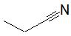
 |  | 1-cyanopropane | 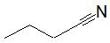
 |  | 2-cyanopropane | 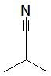
 |  | 1-cyanobutane | 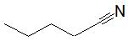
 |  | 2-cyanobutane | 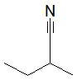
 |  | 2-cyano-2-methylpropane | 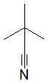
 |  | 1-cyano-2-methylpropane | 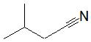
 |  | 1-cyanopentane | 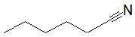
 |  | 2-cyanopentane | 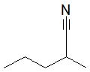
 |  | 3-cyanopentane | 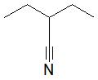
 |  | 1-cyano-2-methylbutane | 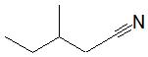
 |  | 2-cyano-2-methylbutane | 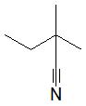
 |  | 2-cyano-3-methylbutane | 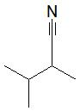
 |  | 1-cyano-2,2-dimethylpropane | 