CHE 102 – CH 23 – Ketones

Total # Carbons | # C Main Chain | IUPAC Name | Linear Structure | Structural Formula
3 |  | propanone | 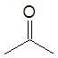
4 |  | butanone | 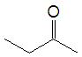
5 | 5 | 2-pentanone | 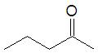
 |  | 3-pentanone | 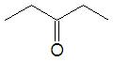
 | 4 | 3-methyl-2-butanone | 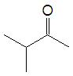
6 | 6 | 2-hexanone | 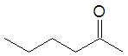
 |  | 3-hexanone | 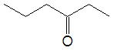
 | 5 | 3-methyl-2-pentanone | 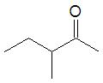
 |  | 4-methyl-2-pentanone | 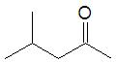
 |  | 2-methyl-3-pentanone | 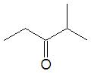
 | 4 | 3,3-dimethyl-2-butanone | 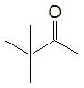
7 | 7 | 2-heptanone | 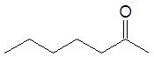
 |  | 3-heptanone | 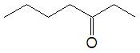
 |  | 4-heptanone | 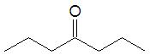
 | 6 | 3-methyl-2-hexanone | 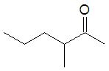
 |  | 4-methyl-2-hexanone | 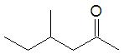
 |  | 5-methyl-2-hexanone | 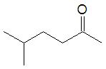
 |  | 2-methyl-3-hexanone | 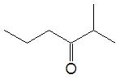
 |  | 4-methyl-3-hexanone | 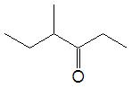
 |  | 5-methyl-3-hexanone | 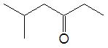
 | 5 | 3,3-dimethyl-2-pentanone | 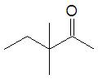
 |  | 3,4-dimethyl-2-pentanone
 |  | 4,4-dimethyl-2-pentanone | 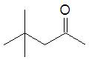
 |  | 3-ethyl-2-pentanone | 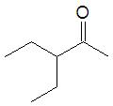
 |  | 2,2-dimethyl-3-pentanone | 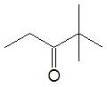
 |  | 2,4-dimethyl-3-pentanone | 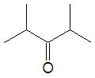
8 | 8 | 2-octanone | 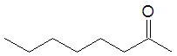
 |  | 3-octanone | 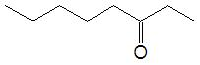
 |  | 4-octanone | 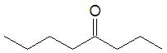
 | 7 | 3-methyl-2-heptanone | 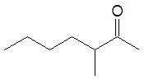
 |  | 4-methyl-2-heptanone | 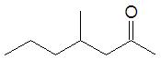
 |  | 5-methyl-2-heptanone | 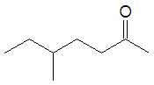
 |  | 6-methyl-2-heptanone | 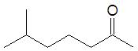
 |  | 2-methyl-3-heptanone | 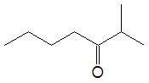
 |  | 4-methyl-3-heptanone | 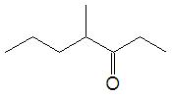
 |  | 5-methyl-3-heptanone | 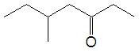
 |  | 6-methyl-3-heptanone | 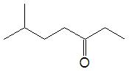
 |  | 2-methyl-4-heptanone | 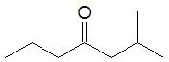
 |  | 3-methyl-4-heptanone | 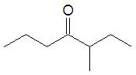
 | 6 | 3,3-dimethyl-2-hexanone | 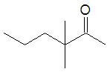
 |  | 3,4-dimethyl-2-hexanone | 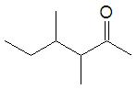
 |  | 3,5-dimethyl-2-hexanone | 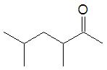
 |  | 4,4-dimethyl-2-hexanone | 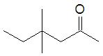
 |  | 4,5-dimethyl-2-hexanone | 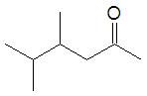
 |  | 5,5-dimethyl-2-hexanone | 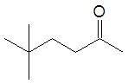
 |  | 2,2-dimethyl-3-hexanone | 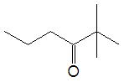
 |  | 2,4-dimethyl-3-hexanone | 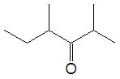
 |  | 2,5-dimethyl-3-hexanone | 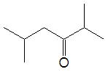
 |  | 4,4-dimethyl-3-hexanone | 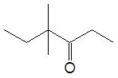
 |  | 4,5-dimethyl-3-hexanone | 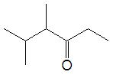
 |  | 5,5-dimethyl-3-hexanone | 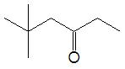
 |  | 3-ethyl-2-hexanone | 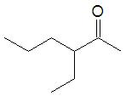
 |  | 4-ethyl-2-hexanone | 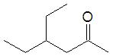
 |  | 4-ethyl-3-hexanone | 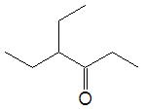
 | 5 | 3,3,4-trimethyl-2-pentanone | 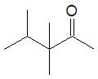
 |  | 3,4,4-trimethyl-2-pentanone | 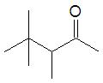
 |  | 3-ethyl-3-methyl-2-pentanone | 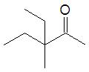
 |  | 3-ethyl-4-methyl-2-pentanone | 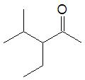
 |  | 2,2,4-trimethyl-3-pentanone | 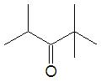
9 | 9 | 2-nonone
 |  | 3-nonone
 |  | 4-nonone
 |  | 5-nonone
 | 8 | 3-methyl-2-octanone
 |  | 4-methyl-2-octanone
 |  | 5-methyl-2-octanone
 |  | 6-methyl-2-octanone
 |  | 7-methyl-2-octanone
 |  | 2-methyl-3-octanone
 |  | 4-methyl-3-octanone
 |  | 5-methyl-3-octanone
 |  | 6-methyl-3-octanone
 |  | 7-methyl-3-octanone
 |  | 2-methyl-4-octanone
 |  | 3-methyl-4-octanone
 |  | 5-methyl-4-octanone
 |  | 6-methyl-4-octanone
 |  | 7-methyl-4-octanone
 | 7 | 3,3-dimethyl-2-heptanone
 |  | 3,4-dimethyl-2-heptanone
 |  | 3,5-dimethyl-2-heptanone
 |  | 3,6-dimethyl-2-heptanone
 |  | 4,4-dimethyl-2-heptanone
 |  | 4,5-dimethyl-2-heptanone
 |  | 4,6-dimethyl-2-heptanone
 |  | 5,5-dimethyl-2-heptanone
 |  | 5,6-dimethyl-2-heptanone
 |  | 6,6-dimethyl-2-heptanone
 |  | 3-ethyl-2-heptanone
 |  | 4-ethyl-2-heptanone
 |  | 5-ethyl-2-heptanone
 |  | 2,2-dimethyl-3-heptanone
 |  | 2,4-dimethyl-3-heptanone
 |  | 2,5-dimethyl-3-heptanone
 |  | 2,6-dimethyl-3-heptanone
 |  | 4,4-dimethyl-3-heptanone
 |  | 4,5-dimethyl-3-heptanone
 |  | 4,6-dimethyl-3-heptanone
 |  | 5,5-dimethyl-3-heptanone
 |  | 5,6-dimethyl-3-heptanone
 |  | 6,6-dimethyl-3-heptanone
 |  | 4-ethyl-3-heptanone
 |  | 5-ethyl-3-heptanone
 |  | 2,2-dimethyl-4-heptanone
 |  | 2,3-dimethyl-4-heptanone
 |  | 2,5-dimethyl-4-heptanone
 |  | 2,6-dimethyl-4-heptanone
 |  | 3,3-dimethyl-4-heptanone
 |  | 3,5-dimethyl-4-heptanone
 |  | 3,6-dimethyl-4-heptanone
 |  | 3-ethyl-4-heptanone
 | 6 | 3,3,4-trimethyl-2-hexanone
 |  | 3,3,5-trimethyl-2-hexanone
 |  | 3,4,4-trimethyl-2-hexanone
 |  | 3,4,5-trimethyl-2-hexanone
 |  | 4,4,5-trimethyl-2-hexanone
 |  | 4,5,5-trimethyl-2-hexanone
 |  | 3-ethyl-3-methyl-2-hexanone
 |  | 3-ethyl-4-methyl-2-hexanone
 |  | 3-ethyl-5-methyl-2-hexanone
 |  | 4-ethyl-3-methyl-2-hexanone
 |  | 4-ethyl-4-methyl-2-hexanone
 |  | 4-ethyl-5-methyl-2-hexanone
 |  | 3-propyl-2-hexanone
 |  | 2,2,4-trimethyl-3-hexanone
 |  | 2,2,5-trimethyl-3-hexanone
 |  | 2,4,4-trimethyl-3-hexanone
 |  | 2,4,5-trimethyl-3-hexanone
 |  | 2,5,5-trimethyl-3-hexanone
 |  | 4,4,5-trimethyl-3-hexanone
 |  | 4,5,5-trimethyl-3-hexanone
 |  | 4-ethyl-2-methyl-3-hexanone
 |  | 4-ethyl-4-methyl-3-hexanone
 |  | 4-ethyl-5-methyl-3-hexanone
 | 5 | 3,3,4,4-tetramethyl-2-pentanone
 |  | 3,3-diethyl-2-pentanone
 |  | 3-ethyl-3,4-dimethyl-2-pentanone
 |  | 3-ethyl-4,4-dimethyl-2-pentanone
 |  | 2,2,4,4-tetramethyl-3-pentanone

