CHE 102 – Ch 24 - Hemiketal

Total # Carbons | # C Main Chain | IUPAC Name | Linear Structure | Structural Formula
4 |  | 2-hydroxy-2-methoxypropane | 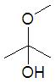
5 |  | 2-hydroxy-2-methoxybutane | 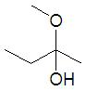
 |  | 2-hydroxy-2-ethoxypropane | 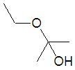
6 |  | 2-hydroxy-2-methoxypentane | 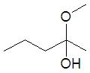
 |  | 3-hydroxy-3-methoxypentane | 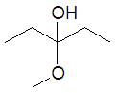
 |  | 2-ethoxy-2-hydroxybutane | 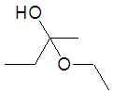
 |  | 2-hydroxy-2-methoxy-3-methylbutane | 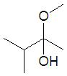
 |  | 2-hydroxy-2-propoxypropane | 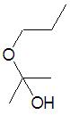
7 |  | 2-hydroxy-2-methoxyhexane
 |  | 3-hydroxy-3-methoxyhexane
 |  | 2-hydroxy-2-methoxy-3-methylpentane
 |  | 2-hydroxy-2-methoxy-4-methylpentane
 |  | 2-ethoxy-2-hydroxypentane
 |  | 3-hydroxy-3-methoxy-2-methylpentane
 |  | 3-ethoxy-3-hydroxypentane | 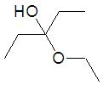
 |  | 2-hydroxy-2-methoxy-3,3-dimethylbutane
 |  | 2-ethoxy-2-hydroxy-3-methylbutane | 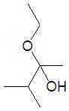
 |  | 2-hydroxy-2-propoxybutane
 |  | 2-hydroxy-2-butoxypropane
8 |  | 2-hydroxy-2-methoxyheptane
 |  | 3-hydroxy-3-methoxyheptane
 |  | 3-hydroxy-4-methoxyheptane
 |  | 2-hydroxy-2-methoxy-3-methylhexane
 |  | 2-hydroxy-2-methoxy-4-methylhexane
 |  | 2-hydroxy-2-methoxy-5-methylhexane
 |  | 2-ethoxy-2-hydroxyhexane
 |  | 3-ethoxy-3-methoxy-2-methylhexane
 |  | 3-ethoxy-3-methoxy-4-methylhexane
 |  | 3-ethoxy-3-methoxy-5-methylhexane
 |  | 3-ethoxy-3-hydroxyhexane
 |  | 2-hydroxy-2-methoxy-3,3-dimethylpentane
 |  | 2-hydroxy-2-methoxy-3,4-dimethylpentane
 |  | 2-hydroxy-2-methoxy-4,4-dimethylpentane
 |  | 3-ethyl-2-hydroxy-2-methoxypentane
 |  | 2-ethoxy-2-hydroxy-3-methylpentane
 |  | 2-ethoxy-2-hydroxy-4-methylpentane
 |  | 2-hydroxy-2-propoxypentane
 |  | 3-hydroxy-3-methoxy-2,2-dimethylpentane
 |  | 3-hydroxy-3-methoxy-2,4-dimethylpentane
 |  | 3-ethoxy-3-hydroxy-2-methylpentane
 |  | 2-ethoxy-2-hydroxy-3,3-dimethylbutane
 |  | 2-hydroxy-2-propoxy-3-methylbutane
 |  | 2-butoxy-2-hydroxybutane
 |  | 2-hydroxy-2-pentoxypropane

