CHE 101 – CH 20 – Alkynes

Total # Carbons | # C Main Chain | IUPAC Name | Linear Structure | Structural Formula
1 |  | None
2 | 1 | methoxymethane | 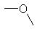
3 | 2 | methoxyethane | 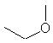
4 | 3 | 1-methoxypropane
 |  | 2-methoxypropane | 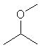
 | 2 | ethoxyethane | 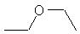
5 | 4 | 1-methoxybutane | 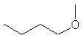
 |  | 2-methoxybutane | 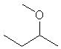
 | 3 | 1-methoxy-2-methylpropane | 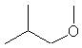
 |  | 1-ethoxypropane | 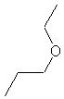
 |  | 2-ethoxypropane | 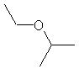
6 | 5 | 1-methoxypentane
 |  | 2-methoxypentane | 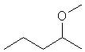
 |  | 3-methoxypentane | 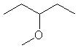
 | 4 | 1-methoxy-2-methylbutane | 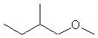
 |  | 2-methoxy-2-methylbutane | 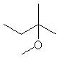
 |  | 2-methoxy-3-methylbutane | 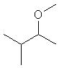
 |  | 1-methoxy-3-methylbutane | 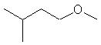
 |  | 1-ethoxybutane | 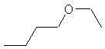
 |  | 2-ethoxybutane | 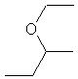
 | 3 | 1-ethoxy-2-methylpropane | 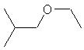
 |  | 2-ethoxy-2-methylpropane | 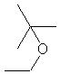
7 | 6 | 1-methoxyhexane | 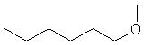
 |  | 2-methoxyhexane | 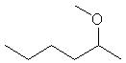
 |  | 3-methoxyhexane
 | 5 | 1-methoxy-2-methylpentane | 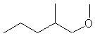
 |  | 1-methoxy-3-methylpentane | 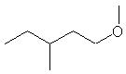
 |  | 1-methoxy-4-methylpentane | 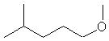
 |  | 2-methoxy-2-methylpentane | 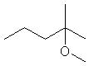
 |  | 2-methoxy-3-methylpentane | 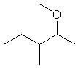
 |  | 2-methoxy-4-methylpentane | 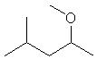
 |  | 3-methoxy-2-methylpentane | 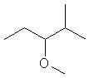
 |  | 3-methoxy-3-methylpentane | 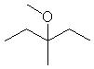
 | 4 | 1-ethoxy-2-methylbutane | 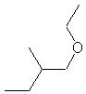
 |  | 1-ethoxy-3-methylbutane | 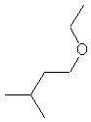
 |  | 2-ethoxy-2-methylbutane | 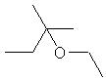
 |  | 2-ethoxy-3-methylbutane | 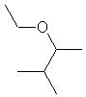
 |  | 1-propoxybutane
 |  | 2-propoxybutane | 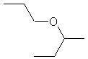
 |  | 1-methoxy-2,2-dimethylbutane | 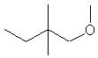
 |  | 1-methoxy-2,3-dimethylbutane | 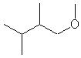
 |  | 1-methoxy-3,3-dimethylbutane | 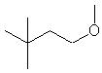
 |  | 2-methoxy-2,3-dimethylbutane | 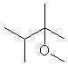
 |  | 2-methoxy-3,3-dimethylbutane | 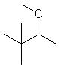
 |  | 1-ethoxy-2,2-dimethylpropane | 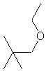
8 | 7 | 1-methoxyheptane
 |  | 2-methoxyheptane | 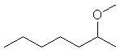
 |  | 3-methoxyheptane | 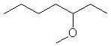
 |  | 4-methoxyheptane | 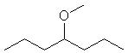
 | 6 | 1-methoxy-2-methylhexane | 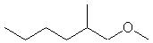
 |  | 1-methoxy-3-methylhexane | 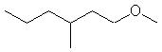
 |  | 1-methoxy-4-methylhexane | 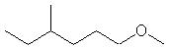
 |  | 1-methoxy-5-methylhexane
 |  | 2-methoxy-2-methylhexane | 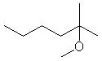
 |  | 2-methoxy-3-methylhexane | 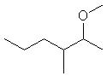
 |  | 2-methoxy-4-methylhexane | 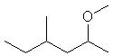
 |  | 2-methoxy-5-methylhexane | 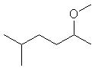
 |  | 3-methoxy-2-methylhexane | 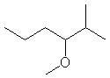
 |  | 3-methoxy-3-methylhexane | 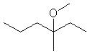
 |  | 3-methoxy-4-methylhexane | 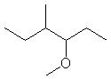
 |  | 3-methoxy-5-methylhexane | 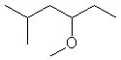
 |  | 1-ethoxyhexane | 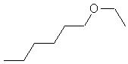
 |  | 2-ethoxyhexane | 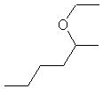
 |  | 3-ethoxyhexane | 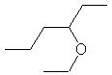
 | 5 | 1-methoxy-2,2-dimethylpentane | 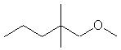
 |  | 1-methoxy-2,3-dimethylpentane | 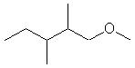
 |  | 1-methoxy-2,4-dimethylpentane | 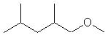
 |  | 1-methoxy-3,3-dimethylpentane | 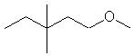
 |  | 1-methoxy-3,4-dimethylpentane | 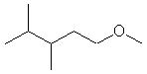
 |  | 1-methoxy-4,4-dimethylpentane | 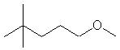
 |  | 1-methoxy-2-ethylpentane | 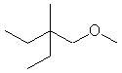
 |  | 1-methoxy-3-ethylpentane | 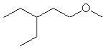
 |  | 1-methoxy-2-propylpentane | 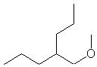
 |  | 2-methoxy-2,3-dimethylpentane | 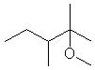
 |  | 2-methoxy-2,4-dimethylpentane | 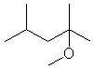
 |  | 2-methoxy-3,3-dimethylpentane | 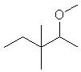
 |  | 2-methoxy-3,4-dimethylpentane | 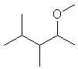
 |  | 2-methoxy-4,4-dimethylpentane | 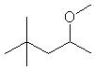
 |  | 2-methoxy-3-ethylpentane | 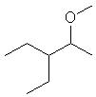
 |  | 3-methoxy-2,2-dimethylpentane | 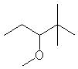
 |  | 3-methoxy-2,3-dimethylpentane | 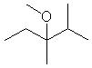
 |  | 3-methoxy-2,4-dimethylpentane | 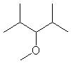
 |  | 3-methoxy-3-ethylpentane | 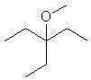
 |  | 1-ethoxy-2-methylpentane | 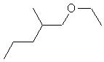
 |  | 1-ethoxy-3-methylpentane | 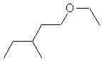
 |  | 1-ethoxy-4-methylpentane | 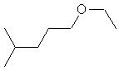
 |  | 2-ethoxy-2-methylpentane | 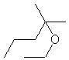
 |  | 2-ethoxy-3-methylpentane | 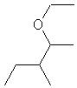
 |  | 2-ethoxy-4-methylpentane | 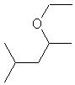
 |  | 3-ethoxy-2-methylpentane | 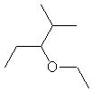
 |  | 3-ethoxy-3-methylpentane | 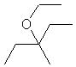
 |  | 1-propoxypentane | 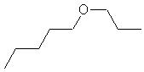
 |  | 2-propoxypentane | 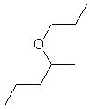
 |  | 3-propoxypentane | 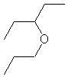
 | 4 | 1-methoxy-2,2,3-trimethylbutane | 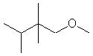
 |  | 1-methoxy-2,3,3-trimethylbutane | 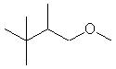
 |  | 1-methoxy-2-ethyl-2-methylbutane
 |  | 1-methoxy-2-ethyl-3-methylbutane | 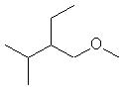
 |  | 2-methoxy-2,3,3-trimethylbutane | 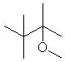
 |  | 1-ethoxy-2,2-dimethylbutane | 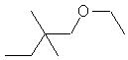
 |  | 1-ethoxy-2,3-dimethylbutane | 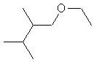
 |  | 1-ethoxy-3,3-dimethylbutane | 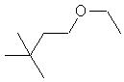
 |  | 2-ethoxy-2,3-dimethylbutane | 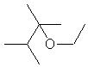
 |  | 2-ethoxy-3,3-dimethylbutane | 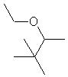
 |  | 1-ethoxy-2-ethylbutane | 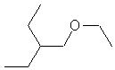
 |  | 1-propoxy-2-methylbutane | 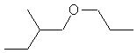
 |  | 1-propoxy-3-methylbutane | 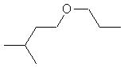
 |  | 2-propoxy-2-methylbutane | 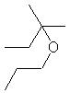
 |  | 2-propoxy-3-methylbutane | 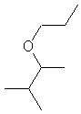
 |  | 1-butoxybutane | 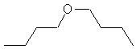
 |  | 2-butoxybutane | 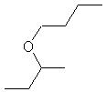
9 | 8 | 1-methoxyoctane
 |  | 2-methoxyoctane
 |  | 3-methoxyoctane
 |  | 4-methoxyoctane
 | 7 | 1-methoxy-2-methylheptane
 |  | 1-methoxy-3-methylheptane
 |  | 1-methoxy-4-methylheptane
 |  | 1-methoxy-5-methylheptane
 |  | 1-methoxy-6-methylheptane
 |  | 2-methoxy-2-methylheptane
 |  | 2-methoxy-3-methylheptane
 |  | 2-methoxy-4-methylheptane
 |  | 2-methoxy-5-methylheptane
 |  | 2-methoxy-6-methylheptane
 |  | 3-methoxy-2-methylheptane
 |  | 3-methoxy-3-methylheptane
 |  | 3-methoxy-4-methylheptane
 |  | 3-methoxy-5-methylheptane
 |  | 3-methoxy-6-methylheptane
 |  | 4-methoxy-2-methylheptane
 |  | 4-methoxy-3-methylheptane
 |  | 4-methoxy-4-methylheptane
 | 6 | 1-ethoxy-2-methylhexane
 |  | 1-ethoxy-3-methylhexane
 |  | 1-ethoxy-4-methylhexane
 |  | 1-ethoxy-5-methylhexane
 |  | 2-ethoxy-2-methylhexane
 |  | 2-ethoxy-3-methylhexane
 |  | 2-ethoxy-4-methylhexane
 |  | 2-ethoxy-5-methylhexane
 |  | 3-ethoxy-2-methylhexane
 |  | 3-ethoxy-3-methylhexane
 |  | 3-ethoxy-4-methylhexane
 |  | 3-ethoxy-5-methylhexane
 |  | 1-propoxyhexane
 |  | 2-propoxyhexane
 |  | 3-propoxyhexane
 |  | 1-methoxy-2,2-dimethylhexane
 |  | 1-methoxy-2,3-dimethylhexane
 |  | 1-methoxy-2,4-dimethylhexane
 |  | 1-methoxy-2,5-dimethylhexane
 |  | 1-methoxy-3,3-dimethylhexane
 |  | 1-methoxy-3,4-dimethylhexane
 |  | 1-methoxy-3,5-dimethylhexane
 |  | 1-methoxy-4,4-dimethylhexane
 |  | 1-methoxy-4,5-dimethylhexane
 |  | 1-methoxy-5,5-dimethylhexane
 |  | 1-methoxy-2-ethylhexane
 |  | 1-methoxy-3-ethylhexane
 |  | 1-methoxy-4-ethylhexane
 |  | 2-methoxy-2,3-dimethylhexane
 |  | 2-methoxy-2,4-dimethylhexane
 |  | 2-methoxy-2,5-dimethylhexane
 |  | 2-methoxy-3,3-dimethylhexane
 |  | 2-methoxy-3,4-dimethylhexane
 |  | 2-methoxy-3,5-dimethylhexane
 |  | 2-methoxy-4,4-dimethylhexane
 |  | 2-methoxy-4,5-dimethylhexane
 |  | 2-methoxy-5,5-dimethylhexane
 |  | 2-methoxy-3-ethylhexane
 |  | 2-methoxy-4-ethylhexane
 |  | 3-methoxy-2,2-dimethylhexane
 |  | 3-methoxy-2,3-dimethylhexane
 |  | 3-methoxy-2,4-dimethylhexane
 |  | 3-methoxy-2,5-dimethylhexane
 |  | 3-methoxy-3,4-dimethylhexane
 |  | 3-methoxy-3,5-dimethylhexane
 |  | 3-methoxy-4,4-dimethylhexane
 |  | 3-methoxy-4,5-dimethylhexane
 |  | 3-methoxy-5,5-dimethylhexane
 |  | 3-methoxy-4-ethylhexane
 | 5 | 1-methoxy-2,2,3-trimethylpentane
 |  | 1-methoxy-2,2,4-trimethylpentane
 |  | 1-methoxy-2,3,3-trimethylpentane
 |  | 1-methoxy-2,3,4-trimethylpentane
 |  | 1-methoxy-3,3,4-trimethylpentane
 |  | 1-methoxy-3,4,4-trimethylpentane
 |  | 1-methoxy-2-ethyl-2-methylpentane
 |  | 1-methoxy-2-ethyl-3-methylpentane
 |  | 1-methoxy-2-ethyl-4-methylpentane
 |  | 1-methoxy-3-ethyl-2-methylpentane
 |  | 1-methoxy-3-ethyl-3-methylpentane
 |  | 1-methoxy-3-ethyl-4-methylpentane
 |  | 1-methoxy-2-propylpentane
 |  | 2-methoxy-2,3,3-trimethylpentane
 |  | 2-methoxy-2,3,4-trimethylpentane
 |  | 2-methoxy-3,3,4-trimethylpentane
 |  | 2-methoxy-3,4,4-trimethylpentane
 |  | 2-methoxy-3-ethyl-2-methylpentane
 |  | 2-methoxy-3-ethyl-3-methylpentane
 |  | 2-methoxy-3-ethyl-4-methylpentane
 |  | 3-methoxy-2,2,3-trimethylpentane
 |  | 3-methoxy-2,2,4-trimethylpentane
 |  | 3-methoxy-3-ethyl-2-methylpentane
 |  | 1-ethoxy-2,2-dimethylpentane
 |  | 1-ethoxy-2,3-dimethylpentane
 |  | 1-ethoxy-2,4-dimethylpentane
 |  | 1-ethoxy-3,3-dimethylpentane
 |  | 1-ethoxy-3,4-dimethylpentane
 |  | 1-ethoxy-4,4-dimethylpentane
 |  | 1-ethoxy-2-ethylpentane
 |  | 1-ethoxy-3-ethylpentane
 |  | 2-ethoxy-2,3-dimethylpentane
 |  | 2-ethoxy-2,4-dimethylpentane
 |  | 2-ethoxy-3,3-dimethylpentane
 |  | 2-ethoxy-3,4-dimethylpentane
 |  | 2-ethoxy-4,4-dimethylpentane
 |  | 2-ethoxy-3-ethylpentane
 |  | 3-ethoxy-2,2-dimethylpentane
 |  | 3-ethoxy-2,3-dimethylpentane
 |  | 3-ethoxy-2,4-dimethylpentane
 |  | 3-ethoxy-3-ethylpentane
 |  | 1-propoxy-2-methylpentane
 |  | 1-propoxy-3-methylpentane
 |  | 1-propoxy-4-methylpentane
 |  | 2-propoxy-2-methylpentane
 |  | 2-propoxy-3-methylpentane
 |  | 2-propoxy-4-methylpentane
 |  | 3-propoxy-2-methylpentane
 |  | 3-propoxy-3-methylpentane
 |  | 1-butoxypentane
 |  | 2-butoxypentane
 |  | 3-butoxypentane
 | 4 | 1-methoxy-2,2,3,3-tetramethylbutane
 |  | 1-methoxy-2-ethyl-2,3-dimethylbutane
 |  | 1-methoxy-2-ethyl-3,3-dimethylbutane
 |  | 1-ethoxy-2,2,3-trimethylbutane
 |  | 1-ethoxy-2,3,3-trimethylbutane
 |  | 1-ethoxy-2-ethyl-2-methylbutane
 |  | 1-ethoxy-2-ethyl-3-methylbutane
 |  | 1-propoxy-2,2-dimethylbutane
 |  | 1-propoxy-2,3-dimethylbutane
 |  | 1-propoxy-3,3-dimethylbutane
 |  | 1-propoxy-2-ethylbutane
 |  | 2-propoxy-3,3-dimethylbutane
 |  | 1-butoxy-2-methylbutane
 |  | 1-butoxy-3-methylbutane
 |  | 2-butoxy-2-methylbutane
 |  | 2-butoxy-3-methylbutane

