CHE 102 – CH 24 – Esters

Total # Carbons | # C Main Chain | IUPAC Name | Linear Structure | Structural Formula
2 |  | methyl methanoate | 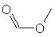
3 |  | methyl ethanoate | 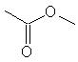
 |  | ethyl methanoate | 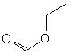
4 |  | methyl propanoate | 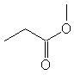
 |  | ethyl ethanoate | 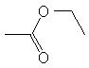
 |  | propyl methanoate | 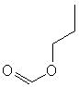
5 |  | methyl butanoate | 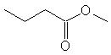
 |  | ethyl propanoate | 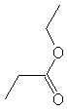
 |  | propyl ethanoate | 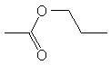
 |  | butyl methanoate | 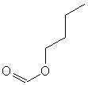
6 |  | methyl pentanoate | 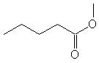
 |  | ethyl butanoate | 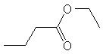
 |  | propyl propanoate | 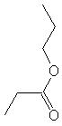
 |  | butyl ethanoate | 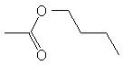
 |  | pentyl methanoate | 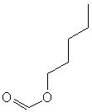
 |  | methyl 2-methylbutanoate | 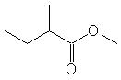
 |  | methyl 3-methylbutanoate | 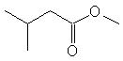
 |  | ethyl 2-methylpropanoate | 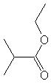
 |  | 2-methylpropyl ethanoate | 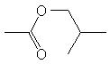
 |  | 2-methylbutyl methanoate | 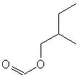
 |  | 3-methylbutyl methanoate | 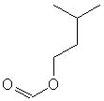
7 |  | methyl hexanoate | 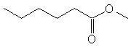
 |  | ethyl pentanoate | 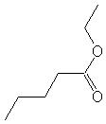
 |  | propyl butanoate | 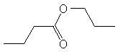
 |  | butyl propanoate | 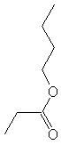
 |  | pentyl ethanoate | 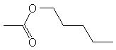
 |  | hexyl methanoate | 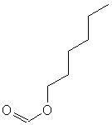
 |  | methyl 2-methylpentanoate | 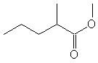
 |  | methyl 3-methylpentanoate | 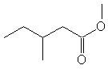
 |  | methyl 4-methylpentanoate | 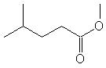
 |  | ethyl 2-methylbutanoate | 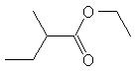
 |  | ethyl 3-methylbutanoate | 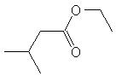
 |  | 2-methylpropyl 2-methylpropanoate | 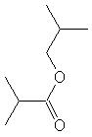
 |  | 2-methylbutyl ethanoate | 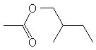
 |  | 3-methylbutyl ethanoate | 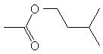
 |  | 2-methylpentyl methanoate | 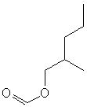
 |  | 3-methylpentyl methanoate | 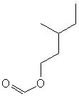
 |  | 4-methylpentyl methanoate | 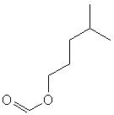
 |  | methyl 2,2-dimethylbutanoate | 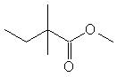
 |  | methyl 2,3-dimethylbutanoate | 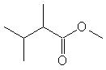
 |  | methyl 3,3-dimethylbutanoate | 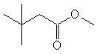
 |  | ethyl 2,2-dimethylpropanoate | 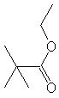
 |  | 2,2-dimethylpropyl ethanoate | 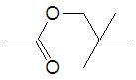
 |  | 2,2-dimethylbutyl methanoate | 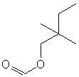
 |  | 2,3-dimethylbutyl methanoate | 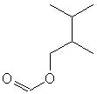
 |  | 3,3-dimethylbutyl methanoate | 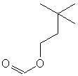
8 |  | methyl heptanoate | 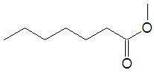
 |  | ethyl hexanoate | 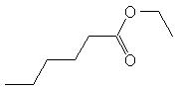
 |  | propyl pentanoate | 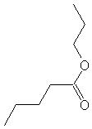
 |  | butyl butanoate | 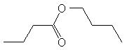
 |  | pentyl propanoate | 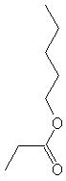
 |  | hexyl ethanoate | 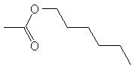
 |  | heptyl methanoate | 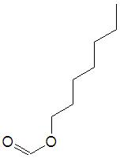
 |  | methyl 2-methylhexanoate | 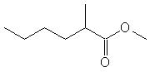
 |  | methyl 3-methylhexanoate | 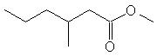
 |  | methyl 4-methylhexanoate | 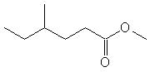
 |  | methyl 5-methylhexanoate | 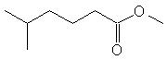
 |  | ethyl 2-methylpentanoate | 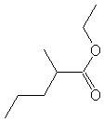
 |  | ethyl 3-methylpentanoate | 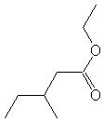
 |  | ethyl 4-methylpentanoate | 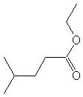
 |  | 2-methylpropyl butanoate | 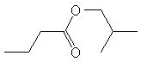
 |  | propyl-2-methyl butanoate | 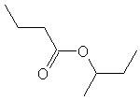
 |  | propyl-3-methyl butanoate | 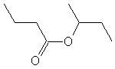
 |  | 2-methylbutyl propanoate | 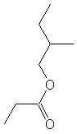
 |  | 3-methylbutyl propanoate | 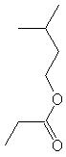
 |  | butyl-2-methyl propanoate | 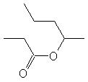
 |  | 2-methylpentyl ethanoate | 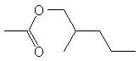
 |  | 3-methylpentyl ethanoate | 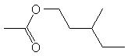
 |  | 4-methylpentyl ethanoate | 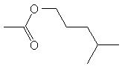
 |  | 2-methylhexyl methanoate | 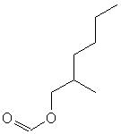
 |  | 3-methylhexyl methanoate | 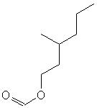
 |  | 4-methylhexyl methanoate | 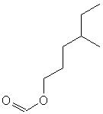
 |  | 5-methylhexyl methanoate | 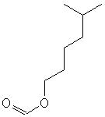
 |  | methyl 2,2-dimethylpentanoate | 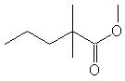
 |  | methyl 2,3-dimethylpentanoate | 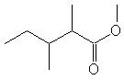
 |  | methyl 2,4-dimethylpentanoate | 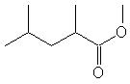
 |  | methyl 3,3-dimethylpentanoate | 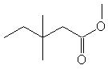
 |  | methyl 3,4-dimethylpentanoate | 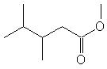
 |  | methyl 4,4-dimethylpentanoate | 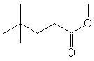
 |  | methyl 2-ethylpentanoate | 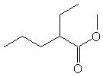
 |  | methyl 3-ethylpentanoate | 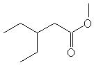
 |  | ethyl 2,2-dimethylbutanoate | 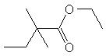
 |  | ethyl 2,3-dimethylbutanoate | 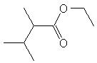
 |  | ethyl 3,3-dimethylbutanoate | 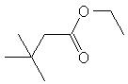
 |  | ethyl 2-ethylbutanoate | 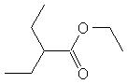
 |  | 2,2-dimethylpropyl propanoate | 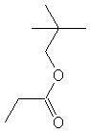
 |  | propyl 2,2-dimethylpropanoate | 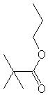
 |  | 2-methylpropyl 2-methylpropanoate | 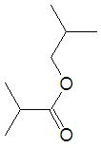
 |  | 2,2-dimethylbutyl ethanoate | 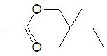
 |  | 2,3-dimethylbutyl ethanoate | 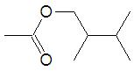
 |  | 3,3-dimethylbutyl ethanoate | 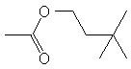
 |  | 2-ethylbutyl ethanoate | 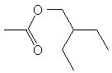
 |  | 2,2-dimethylpentylmethanoate | 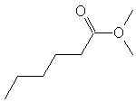
 |  | 2,3-dimethylpentyl methanoate | 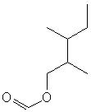
 |  | 2,4-dimethylpentyl methanoate | 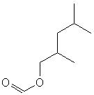
 |  | 3,3-dimethylpentyl methanoate | 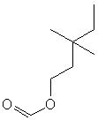
 |  | 3,4-dimethylpentyl methanoate | 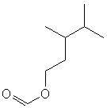
 |  | 4,4-dimethylpentyl methanoate | 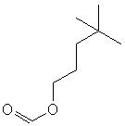
 |  | 2-ethylpentyl methanoate | 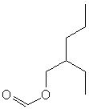
 |  | 3-ethylpentyl methanoate | 