CHE 102 – Misc – enes + ols

Total # Carbons | # C Main Chain | IUPAC Name | Linear Structure | Structural Formula
2 | 2 | ethanol
3 | 3 | 1-propene-1-ol
 |  | 2-propene-1-ol
 |  | 2-propene-2-ol | 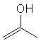
4 | 4 | 1-butene-1-ol
 |  | 2-butene-1-ol
 |  | 3-butene-1-ol
 |  | 1-butene-2-ol | 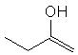
 |  | 2-butene-2-ol | 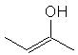
 |  | 3-butene-2-ol | 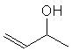
 | 3 | 2-methyl-1-propene-1-ol | 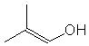
 |  | 2-methyl-2-propene-1-ol | 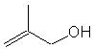
5 | 5 | 1-pentene-1-ol
 |  | 2-pentene-1-ol
 |  | 3-pentene-1-ol
 |  | 4-pentene-1-ol
 |  | 1-pentene-2-ol | 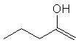
 |  | 2-pentene-2-ol | 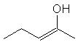
 |  | 3-pentene-2-ol | 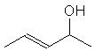
 |  | 4-pentene-2-ol | 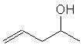
 |  | 1-pentene-3-ol | 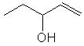
 |  | 2-pentene-3-ol | 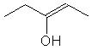
 | 4 | 2-methyl-1-butene-1-ol | 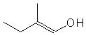
 |  | 3-methyl-1-butene-1-ol | 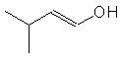
 |  | 2-methyl-2-butene-1-ol | 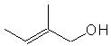
 |  | 3-methyl-2-butene-1-ol | 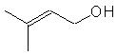
 |  | 2-methyl-3-butene-1-ol | 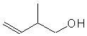
 |  | 3-methyl-3-butene-1-ol | 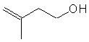
 |  | 2-methyl-1-butene-2-ol | 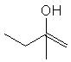
 |  | 3-methyl-2-butene-2-ol | 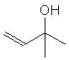
 |  | 2-methyl-3-butene-2-ol
 |  | 3-methyl-3-butene-2-ol | 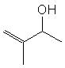
 | 3 | 2,2-dimethyl-1-propene-1-ol | 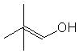
 |  | 2,2-dimethyl-2-propene-1-ol | 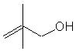
 |  | 2-ethyl-2-propene-ol | 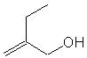
6 | 6 | 1-hexene-1-ol
 |  | 2-hexene-1-ol
 |  | 3-hexene-1-ol
 |  | 4-hexene-1-ol
 |  | 5-hexene-1-ol
 |  | 1-hexene-2-ol | 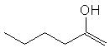
 |  | 2-hexene-2-ol | 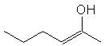
 |  | 3-hexene-2-ol | 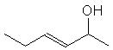
 |  | 4-hexene-2-ol | 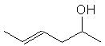
 |  | 5-hexene-2-ol | 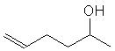
 |  | 1-hexene-3-ol | 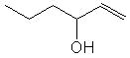
 |  | 2-hexene-3-ol | 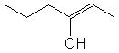
 |  | 3-hexene-3-ol | 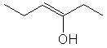
 |  | 4-hexene-3-ol | 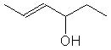
 |  | 5-hexene-3-ol | 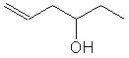
 | 5 | 2-methyl-1-pentene-1-ol | 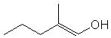
 |  | 2-methyl-2-pentene-1-ol | 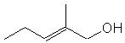
 |  | 2-methyl-3-pentene-1-ol | 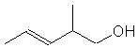
 |  | 2-methyl-4-pentene-1-ol | 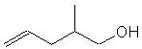
 |  | 3-methyl-1-pentene-1-ol | 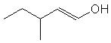
 |  | 3-methyl-2-pentene-1-ol | 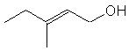
 |  | 3-methyl-3-pentene-1-ol | 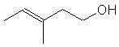
 |  | 3-methyl-4-pentene-1-ol | 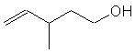
 |  | 4-methyl-1-pentene-1-ol | 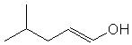
 |  | 4-methyl-2-pentene-1-ol | 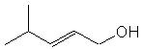
 |  | 4-methyl-3-pentene-1-ol | 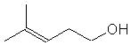
 |  | 4-methyl-4-pentene-1-ol | 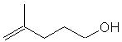
 |  | 2-methyl-3-pentene-2-ol | 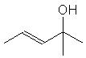
 |  | 2-methyl-4-pentene-2-ol | 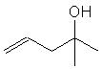
 |  | 3-methyl-1-pentene-2-ol | 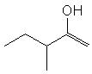
 |  | 3-methyl-2-pentene-2-ol | 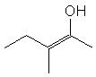
 |  | 3-methyl-3-pentene-2-ol | 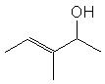
 |  | 3-methyl-4-pentene-2-ol | 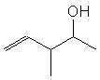
 |  | 4-methyl-1-pentene-2-ol | 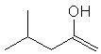
 |  | 4-methyl-2-pentene-2-ol | 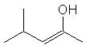
 |  | 4-methyl-3-pentene-2-ol | 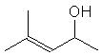
 |  | 4-methyl-4-pentene-2-ol | 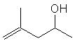
 |  | 2-methyl-1-pentene-3-ol | 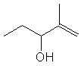
 |  | 2-methyl-2-pentene-3-ol | 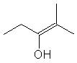
 |  | 4-methyl-1-pentene-3-ol | 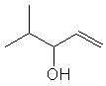
 |  | 4-methyl-2-pentene-3-ol | 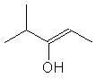
 |  | 3-methyl-1-pentene-3-ol | 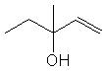
 | 4 | 2,2-dimethyl-3-butene-1-ol | 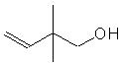
 |  | 3,3-dimethyl-1-butene-1-ol | 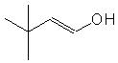
 |  | 2,3-dimethyl-1-butene-1-ol | 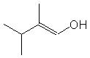
 |  | 2,3-dimethyl-2-butene-1-ol | 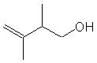
 |  | 2,3-dimethyl-3-butene-1-ol
 |  | 2,3-dimethyl-3-butene-2-ol | 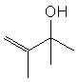
 |  | 3,3-dimethyl-1-butene-2-ol | 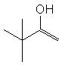
 |  | 2-ethyl-1-butene-1-ol | 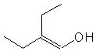
 |  | 2-ethyl-2-butene-1-ol | 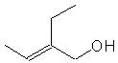
 | 3 | 2-propyl-2-propene-1-ol | 