CHE 102 – Misc – di-Haloalkanes

Total # Carbons | # C Main Chain | IUPAC Name | Linear Structure | Structural Formula
1 | 1 | dichloromethane | 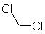
2 | 2 | 1,1-dichloroethane | 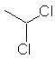
 |  | 1,2-dichloroethane | 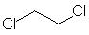
3 | 3 | 1,1-dichloropropane | 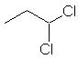
 |  | 1,2-dichloropropane | 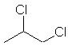
 |  | 1,3-dichloropropane
4 | 4 | 1,1-dichlorobutane | 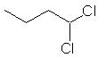
 |  | 1,2-dichlorobutane | 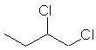
 |  | 1,3-dichlorobutane | 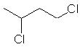
 |  | 1,4-dichlorobutane | 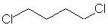
 |  | 2,2-dichlorobutane | 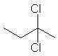
 |  | 2,3-dichlorobutane | 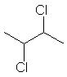
5 | 5 | 1,1-dichloropentane | 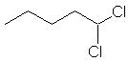
 |  | 1,2-dichloropentane | 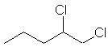
 |  | 1,3-dichloropentane | 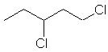
 |  | 1,4-dichloropentane | 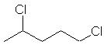
 |  | 1,5-dichloropentane
 |  | 2,2-dichloropentane | 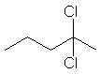
 |  | 2,3-dichloropentane | 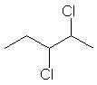
 |  | 2,4-dichloropentane | 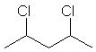
 |  | 3,3-dichloropentane | 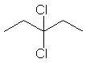
6 | 6 | 1,1-dichlorohexane | 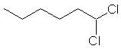
 |  | 1,2-dichlorohexane | 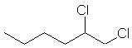
 |  | 1,3-dichlorohexane | 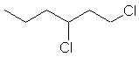
 |  | 1,4-dichlorohexane | 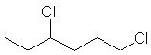
 |  | 1,5-dichlorohexane | 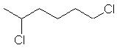
 |  | 1,6-dichlorohexane | 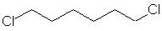
 |  | 2,2-dichlorohexane | 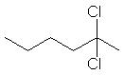
 |  | 2,3-dichlorohexane | 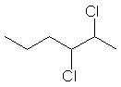
 |  | 2,4-dichlorohexane | 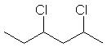
 |  | 2,5-dichlorohexane | 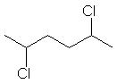
 |  | 3,3-dichlorohexane | 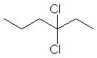
 |  | 3,4-dichlorohexane | 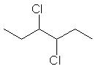
7 | 7 | 1,1-dichloroheptane | 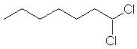
 |  | 1,2-dichloroheptane | 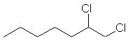
 |  | 1,3-dichloroheptane | 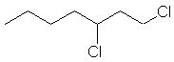
 |  | 1,4-dichloroheptane | 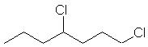
 |  | 1,5-dichloroheptane | 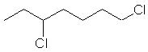
 |  | 1,6-dichloroheptane | 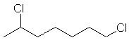
 |  | 1,7-dichloroheptane
 |  | 2,2-dichloroheptane | 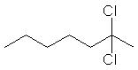
 |  | 2,3-dichloroheptane | 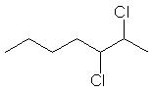
 |  | 2,4-dichloroheptane | 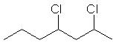
 |  | 2,5-dichloroheptane | 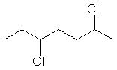
 |  | 2,6-dichloroheptane | 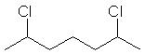
 |  | 3,3-dichloroheptane | 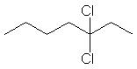
 |  | 3,4-dichloroheptane | 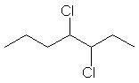
 |  | 3,5-dichloroheptane | 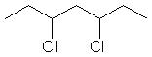
 |  | 4,4-dichloroheptane | 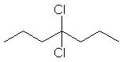
8 | 8 | 1,1-dichlorooctane | 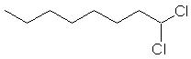
 |  | 1,2-dichlorooctane | 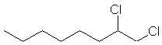
 |  | 1,3-dichlorooctane | 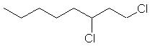
 |  | 1,4-dichlorooctane | 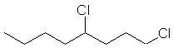
 |  | 1,5-dichlorooctane | 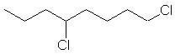
 |  | 1,6-dichlorooctane | 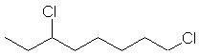
 |  | 1,7-dichlorooctane | 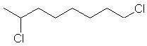
 |  | 1,8-dichlorooctane | 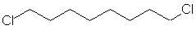
 |  | 2,2-dichlorooctane | 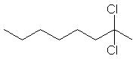
 |  | 2,3-dichlorooctane | 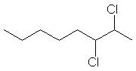
 |  | 2,4-dichlorooctane | 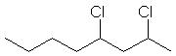
 |  | 2,5-dichlorooctane | 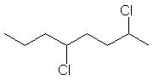
 |  | 2,6-dichlorooctane | 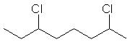
 |  | 2,7-dichlorooctane | 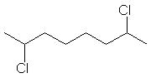
 |  | 3,3-dichlorooctane | 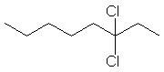
 |  | 3,4-dichlorooctane | 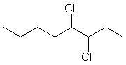
 |  | 3,5-dichlorooctane | 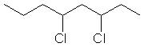
 |  | 3,6-dichlorooctane | 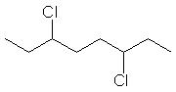
 |  | 4,4-dichlorooctane | 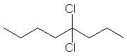
 |  | 4,5-dichlorooctane | 