CHE 101 – CH 24 – Acid Chlorides

Total # Carbons | # C Main Chain | IUPAC Name | Linear Structure | Structural Formula
 |  | 1-chloroethanal | 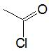
 |  | 1-chloropropanal | 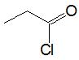
 |  | 1-chlorobutanal | 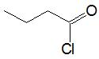
 |  | 1-chloro-2-methylbutanal | 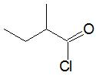
 |  | 1-chloro-2,2-dimethylbutanal | 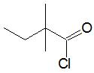
 |  | 1-chloro-2,3-dimethylbutanal | 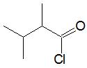
 |  | 1-chloro-2-ethylbutanal | 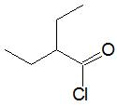
 |  | 1-chloro-3-methylpentanal | 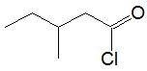
 |  | 1-chloro-2-methylpentanal | 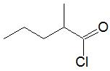
 |  | 1-chloropentanal | 