CHE 102 – CH 25 – Amines

Total # Carbons | # C Main Chain | IUPAC Name | Linear Structure | Structural Formula
1 |  | methanamine
2 |  | ethanamine
 |  | N-methylmethanamine
3 |  | 1-propanamine
 |  | 2-propanamine | 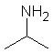
 |  | N,N-dimethylmethanamine | 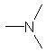
 |  | N-methylethanamine
4 |  | 1-butanamine
 |  | 2-butanamine | 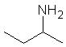
 |  | N-methyl-1-propanamine | 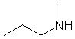
 |  | N-methyl-2-propanamine | 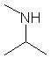
 |  | N,N-dimethylethanamine | 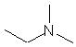
 |  | N-ethylethanamine | 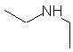
5 |  | 1-pentanamine
 |  | 2-pentanamine | 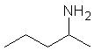
 |  | 3-pentanamine | 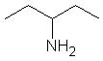
 |  | 2-methyl-1-butanamine | 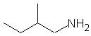
 |  | 3-methyl-1-butanamine | 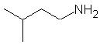
 |  | 2-methyl-2-butanamine | 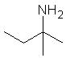
 |  | 3-methyl-2-butanamine | 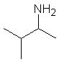
 |  | N-methyl-1-butanamine
 |  | N-methyl-2-butanamine | 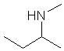
 |  | 2,2-dimethyl-1-propanamine | 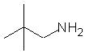
 |  | N-methyl-2-methyl-1-propanamine | 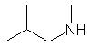
 |  | N-methyl-2-methyl-2-propanamine | 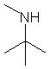
 |  | N,N-dimethyl-1-propanamine | 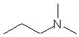
 |  | N,N-dimethyl-2-propanamine | 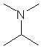
6 |  | 1-hexanamine
 |  | 2-hexanamine | 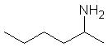
 |  | 3-hexanamine | 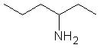
 |  | 2-methyl-1-pentanamine | 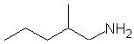
 |  | 3-methyl-1-pentanamine | 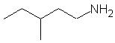
 |  | 4-methyl-1-pentanamine | 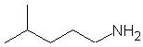
 |  | 2-methyl-2-pentanamine | 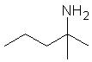
 |  | 3-methyl-2-pentanamine | 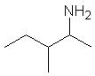
 |  | 4-methyl-2-pentanamine | 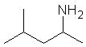
 |  | 2-methyl-3-pentanamine | 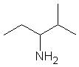
 |  | 3-methyl-3-pentanamine | 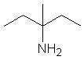
 |  | 4-methyl-3-pentanamine | 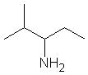
 |  | N-methyl-1-pentanamine | 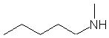
 |  | N-methyl-2-pentanamine | 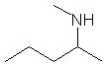
 |  | N-methyl-3-pentanamine | 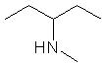
 |  | 2,2-dimethyl-1-butanamine | 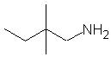
 |  | 2,3-dimethyl-1-butanamine | 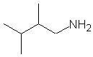
 |  | 3,3-dimethyl-1-butanamine | 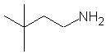
 |  | 2,3-dimethyl-2-butanamine | 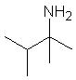
 |  | 3,3-dimethyl-2-butanamine | 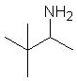
 |  | N-methyl-2-methyl-1-butanamine | 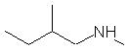
 |  | N-methyl-3-methyl-1-butanamine | 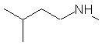
 |  | N-methyl-2-methyl-2-butanamine | 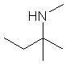
 |  | N-methyl-3-methyl-2-butanamine | 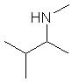
 |  | N,N-dimethyl-1-butanamine | 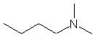
 |  | N,N-dimethyl-2-butanamine | 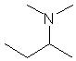
7 |  | 1-heptanamine
 |  | 2-heptanamine | 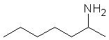
 |  | 3-heptanamine | 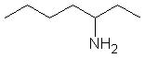
 |  | 4-heptanamine | 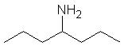
 |  | 2-methyl-1-hexanamine | 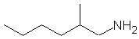
 |  | 3-methyl-1-hexanamine | 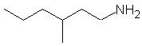
 |  | 4-methyl-1-hexanamine | 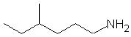
 |  | 5-methyl-1-hexanamine | 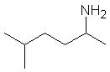
 |  | 2-methyl-2-hexanamine | 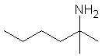
 |  | 3-methyl-2-hexanamine | 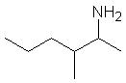
 |  | 4-methyl-2-hexanamine | 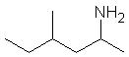
 |  | 5-methyl-2-hexanamine
 |  | 2-methyl-3-hexanamine | 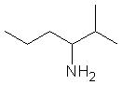
 |  | 3-methyl-3-hexanamine | 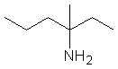
 |  | N-methyl-1-hexanamine
 |  | N-methyl-2-hexanamine | 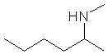
 |  | N-methyl-3-hexanamine | 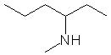
 |  | 2,2-dimethyl-1-pentanamine | 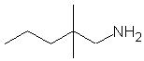
 |  | 2,3-dimethyl-1-pentanamine | 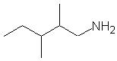
 |  | 2,4-dimethyl-1-pentanamine | 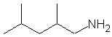
 |  | 3,3-dimethyl-1-pentanamine | 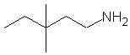
 |  | 3,4-dimethyl-1-pentanamine | 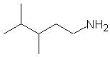
 |  | 4,4-dimethyl-1-pentanamine | 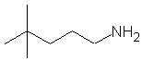
 |  | N-methyl-2-methyl-1-pentanamine | 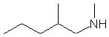
 |  | N-methyl-3-methyl-1-pentanamine | 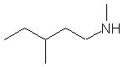
 |  | N-methyl-4-methyl-1-pentanamine | 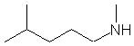
 |  | N,N-dimethyl-1-pentanamine | 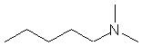
 |  | 2-ethyl-1-pentanamine | 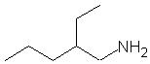
 |  | 3-ethyl-1-pentanamine | 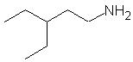
 |  | N-ethyl-1-pentanamine | 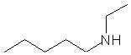
 |  | 2,3-dimethyl-2-pentanamine | 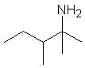
 |  | 2,4-dimethyl-2-pentanamine | 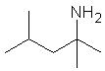
 |  | 3,3-dimethyl-2-pentanamine | 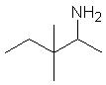
 |  | 3,4-dimethyl-2-pentanamine | 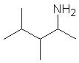
 |  | 4,4-dimethyl-2-pentanamine | 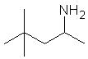
 |  | N-methyl-2-methyl-2-pentanamine | 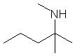
 |  | N-methyl-3-methyl-2-pentanamine | 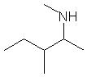
 |  | N-methyl-4-methyl-2-pentanamine | 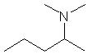
 |  | N,N-dimethyl-2-pentanamine
 |  | 3-ethyl-2-pentanamine | 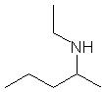
 |  | N-ethyl-2-pentanamine
 |  | 2,2-dimethyl-3-pentanamine | 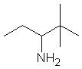
 |  | 2,3-dimethyl-3-pentanamine | 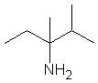
 |  | 2,4-dimethyl-3-pentanamine | 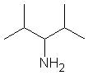
 |  | N-methyl-2-methyl-3-pentanamine | 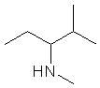
 |  | N-methyl-3-methyl-3-pentanamine | 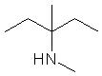
 |  | N,N-dimethyl-3-pentanamine | 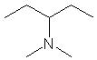
 |  | 3-ethyl-3-pentanamine | 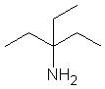
 |  | N-ethyl-3-pentanamine | 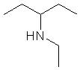
 | 4 | 2,2,3-trimethyl-1-butanamine | 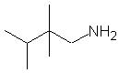
 |  | 2,3,3-trimethyl-1-butanamine | 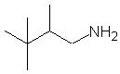
 |  | N-methyl-2,2-dimethyl-1-butanamine | 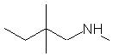
 |  | N-methyl-2,3-dimethyl-1-butanamine | 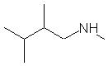
 |  | N-methyl-3,3-dimethyl-1-butanamine | 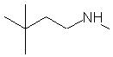
 |  | N,N-dimethyl-2-methyl-1-butanamine | 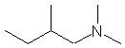
 |  | N,N-dimethyl-3-methyl-1-butanamine | 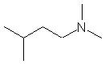
 |  | N-ethyl-2-methyl-1-butanamine | 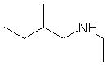
 |  | N-ethyl-3-methyl-1-butanamine | 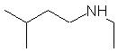
 |  | 2-ethyl-2-methyl-1-butanamine | 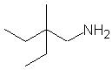
 |  | 2-ethyl-3-methyl-1-butanamine | 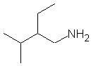
 |  | 2,3,3-trimethyl-2-butanamine | 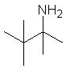
 |  | N-methyl-2,3-dimethyl-2-butanamine | 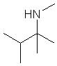
 |  | N-methyl-3,3-dimethyl-2-butanamine | 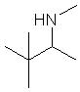
 |  | N,N-dimethyl-2-methyl-2-butanamine | 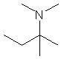
 |  | N,N-dimethyl-3-methyl-2-butanamine | 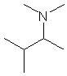
 |  | N-ethyl-2-methyl-2-butanamine | 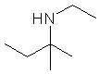
 |  | N-ethyl-3-methyl-2-butanamine | 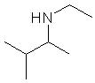
 |  | N-propyl-2-methyl-1-propanamine | 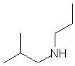
 |  | N-methyl-N-propyl-1-propanamine | 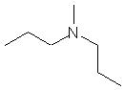
 |  | N,N-dimethyl-2,2-dimethyl-1-propanamine | 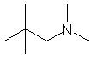
 |  | N-ethyl-N-methyl-2-methyl-1-propanamine | 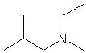
 |  | N-ethyl-2,2-dimethyl-1-propanamine | 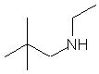
8 |  | 1-octanamine
 |  | 2-octanamine | 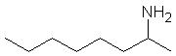
 |  | 3-octanamine | 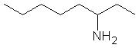
 |  | 4-octanamine | 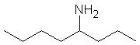
8 | 7 | 2-methyl-1-heptanamine | 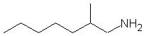
 |  | 3-methyl-1-heptanamine | 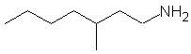
 |  | 4-methyl-1-heptanamine | 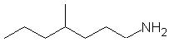
 |  | 5-methyl-1-heptanamine | 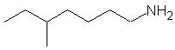
 |  | 6-methyl-1-heptanamine | 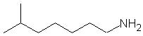
 |  | N-methyl-1-heptanamine | 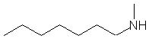
 |  | 2-methyl-2-heptanamine | 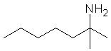
 |  | 3-methyl-2-heptanamine | 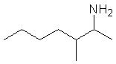
 |  | 4-methyl-2-heptanamine | 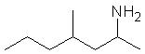
 |  | 5-methyl-2-heptanamine | 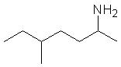
 |  | 6-methyl-2-heptanamine | 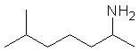
 |  | N-methyl-2-heptanamine | 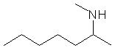
 |  | 2-methyl-3-heptanamine | 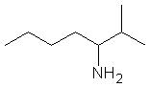
 |  | 3-methyl-3-heptanamine | 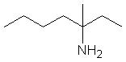
 |  | 4-methyl-3-heptanamine | 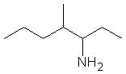
 |  | 5-methyl-3-heptanamine | 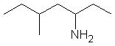
 |  | 6-methyl-3-heptanamine | 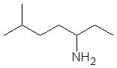
 |  | N-methyl-3-heptanamine | 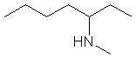
 |  | 2-methyl-4-heptanamine | 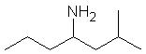
 |  | 3-methyl-4-heptanamine | 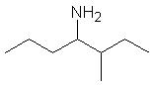
 |  | 4-methyl-4-heptanamine | 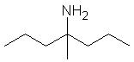
 |  | N-methyl-4-heptanamine | 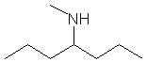
8 | 6 | 2,2-dimethyl-1-hexanamine | 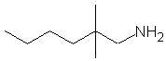
 |  | 2,3-dimethyl-1-hexanamine | 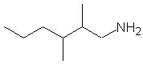
 |  | 2,4-dimethyl-1-hexanamine | 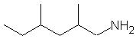
 |  | 2,5-dimethyl-1-hexanamine | 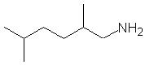
 |  | 3,3-dimethyl-1-hexanamine | 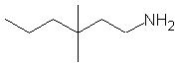
 |  | 3,4-dimethyl-1-hexanamine | 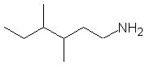
 |  | 3,5-dimethyl-1-hexanamine | 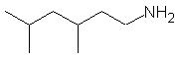
 |  | 4,4-dimethyl-1-hexanamine | 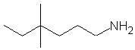
 |  | 4,5-dimethyl-1-hexanamine | 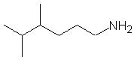
 |  | 5,5-dimethyl-1-hexanamine | 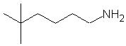
 |  | N-methyl-2-methyl-1-hexanamine | 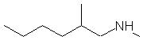
 |  | N-methyl-3-methyl-1-hexanamine | 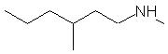
 |  | N-methyl-4-methyl-1-hexanamine | 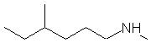
 |  | N-methyl-5-methyl-1-hexanamine
 |  | N,N-dimethyl-1-hexanamine | 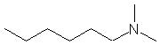
 |  | 2-ethyl-1-hexanamine | 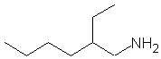
 |  | 3-ethyl-1-hexanamine | 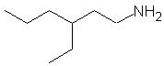
 |  | 4-ethyl-1-hexanamine | 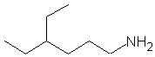
 |  | N-ethyl-1-hexanamine | 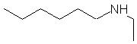
 |  | 2,3-dimethyl-2-hexanamine | 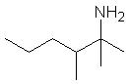
 |  | 2,4-dimethyl-2-hexanamine | 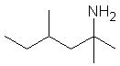
 |  | 2,5-dimethyl-2-hexanamine | 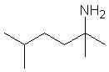
 |  | 3,3-dimethyl-2-hexanamine | 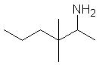
 |  | 3,4-dimethyl-2-hexanamine | 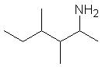
 |  | 3,5-dimethyl-2-hexanamine | 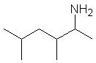
 |  | 4,4-dimethyl-2-hexanamine | 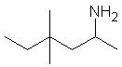
 |  | 4,5-dimethyl-2-hexanamine | 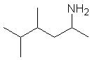
 |  | 5,5-dimethyl-2-hexanamine | 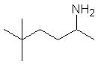
 |  | N-methyl-2-methyl-2-hexanamine | 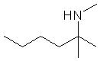
 |  | N-methyl-3-methyl-2-hexanamine | 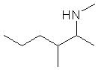
 |  | N-methyl-4-methyl-2-hexanamine | 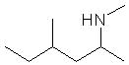
 |  | N-methyl-5-methyl-2-hexanamine | 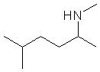
 |  | N,N-dimethyl-2-hexanamine | 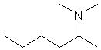
 |  | 3-ethyl-2-hexanamine | 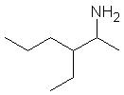
 |  | 4-ethyl-2-hexanamine | 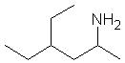
 |  | N-ethyl-2-hexanamine | 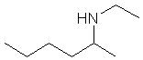
 |  | 2,2-dimethyl-3-hexanamine | 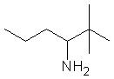
 |  | 2,3-dimethyl-3-hexanamine | 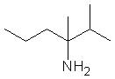
 |  | 2,4-dimethyl-3-hexanamine | 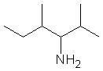
 |  | 2,5-dimethyl-3-hexanamine | 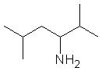
 |  | 3,4-dimethyl-3-hexanamine | 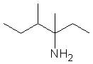
 |  | 3,5-dimethyl-3-hexanamine | 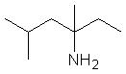
 |  | 4,4-dimethyl-3-hexanamine | 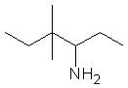
 |  | 4,5-dimethyl-3-hexanamine | 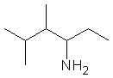
 |  | 5,5-dimethyl-3-hexanamine | 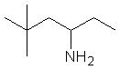
 |  | N-methyl-2-methyl-3-hexanamine | 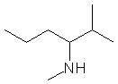
 |  | N-methyl-3-methyl-3-hexanamine | 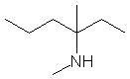
 |  | N-methyl-4-methyl-3-hexanamine | 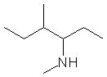
 |  | N-methyl-5-methyl-3-hexanamine | 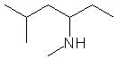
 |  | 3-ethyl-3-hexanamine | 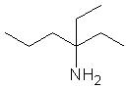
 |  | 4-ethyl-3-hexanamine | 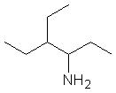
 |  | N-ethyl-3-hexanamine | 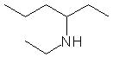
 | 5 | 2,2,3-trimethyl-1-pentanamine | 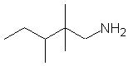
 |  | 2,2,4-trimethyl-1-pentanamine | 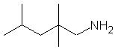
 |  | 2,3,3-trimethyl-1-pentanamine | 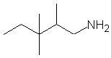
 |  | 2,3,4-trimethyl-1-pentanamine | 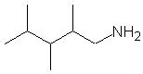
 |  | 3,3,4-trimethyl-1-pentanamine | 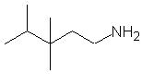
 |  | 3,4,4-trimethyl-1-pentanamine | 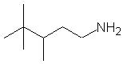
 |  | N-methyl-2,2-dimethyl-1-pentanamine | 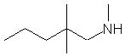
 |  | N-methyl-2,3-dimethyl-1-pentanamine | 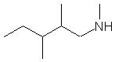
 |  | N-methyl-2,4-dimethyl-1-pentanamine | 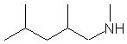
 |  | N-methyl-3,3-dimethyl-1-pentanamine | 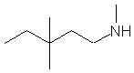
 |  | N-methyl-3,4-dimethyl-1-pentanamine | 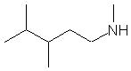
 |  | N-methyl-4,4-dimethyl-1-pentanamine | 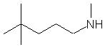
 |  | N-ethyl-2-methyl-1-pentanamine | 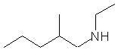
 |  | N-ethyl-3-methyl-1-pentanamine | 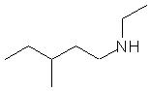
 |  | N-ethyl-4-methyl-1-pentanamine | 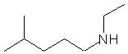
 |  | N-ethyl-N-methyl-1-pentanamine | 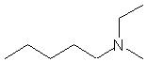
 |  | N,N-dimethyl-2-methyl-1-pentanamine | 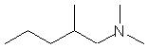
 |  | N,N-dimethyl-3-methyl-1-pentanamine | 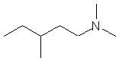
 |  | N,N-dimethyl-4-methyl-1-pentanamine | 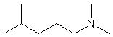
 |  | 2-ethyl-2-methyl-1-pentanamine | 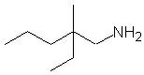
 |  | 2-ethyl-3-methyl-1-pentanamine | 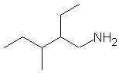
 |  | 2-ethyl-4-methyl-1-pentanamine | 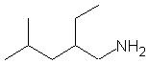
 |  | 3-ethyl-2-methyl-1-pentanamine | 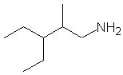
 |  | 3-ethyl-3-methyl-1-pentanamine | 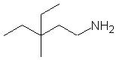
 |  | 3-ethyl-4-methyl-1-pentanamine | 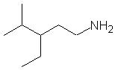
 |  | 2-propyl-1-pentanamine | 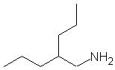
 |  | N-propyl-1-pentanamine | 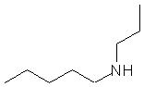
 |  | 2,3,3-trimethyl-2-pentanamine | 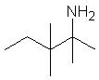
 |  | 2,3,4-trimethyl-2-pentanamine | 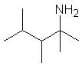
 |  | 2,4,4-trimethyl-2-pentanamine | 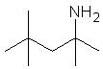
 |  | 3,3,4-trimethyl-2-pentanamine | 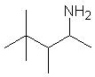
 |  | 3,4,4-trimethyl-2-pentanamine
 |  | N-methyl-2,3-dimethyl-2-pentanamine | 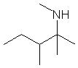
 |  | N-methyl-2,4-dimethyl-2-pentanamine | 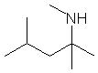
 |  | N-methyl-3,3-dimethyl-2-pentanamine | 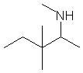
 |  | N-methyl-3,4-dimethyl-2-pentanamine | 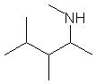
 |  | N-methyl-4,4-dimethyl-2-pentanamine | 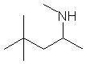
 |  | N,N-dimethyl-2-methyl-2-pentanamine | 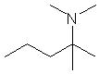
 |  | N,N-dimethyl-3-methyl-2-pentanamine | 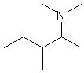
 |  | N,N-dimethyl-4-methyl-2-pentanamine | 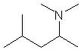
 |  | N-ethyl-2-methyl-2-pentanamine | 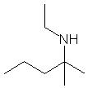
 |  | N-ethyl-3-methyl-2-pentanamine | 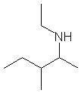
 |  | N-ethyl-4-methyl-2-pentanamine | 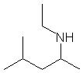
 |  | N-propyl-2-pentanamine | 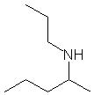
 |  | 2-ethyl-3-methyl-2-pentanamine | 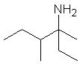
 |  | 2-ethyl-4-methyl-2-pentanamine | 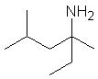
 |  | 3-ethyl-2-methyl-2-pentanamine | 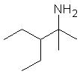
 |  | 3-ethyl-3-methyl-2-pentanamine | 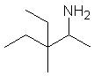
 |  | 3-ethyl-4-methyl-2-pentanamine | 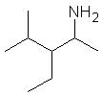
 |  | 2,2,3-trimethyl-3-pentanamine | 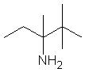
 |  | 2,2,4-trimethyl-3-pentanamine | 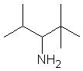
 |  | 2,3,4-trimethyl-3-pentanamine | 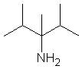
 |  | N-methyl-2,2-dimethyl-3-pentanamine | 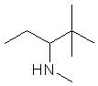
 |  | N-methyl-2,3-dimethyl-3-pentanamine | 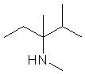
 |  | N-methyl-2,4-dimethyl-3-pentanamine | 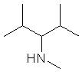
 |  | N,N-dimethyl-2-methyl-3-pentanamine | 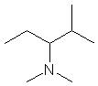
 |  | N,N-dimethyl-3-methyl-3-pentanamine | 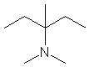
 |  | N-ethyl-2-methyl-3-pentanamine | 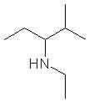
 |  | N-ethyl-3-methyl-3-pentanamine | 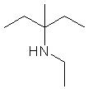
 |  | N-ethyl-N-methyl-3-pentanamine
 |  | N-propyl-3-pentanamine | 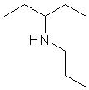
 |  | 3-ethyl-2-methyl-3-pentanamine | 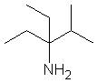
 | 4 | 2,2,4,4-tetramethyl-1-butanamine
 |  | N-methyl-2,2,3-trimethyl-1-butanamine | 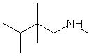
 |  | N-methyl-2,3,3-trimethyl-1-butanamine | 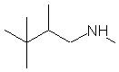
 |  | N,N-dimethyl-2,2-dimethyl-1-butanamine | 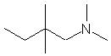
 |  | N,N-dimethyl-2,3-dimethyl-1-butanamine | 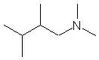
 |  | N,N-dimethyl-3,3-dimethyl-1-butanamine | 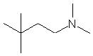
 |  | N-ethyl-N-methyl-2-methyl-1-butanamine | 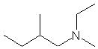
 |  | N-ethyl-N-methyl-3-methyl-1-butanamine | 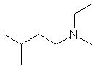
 |  | N,N-diethyl-1-butanamine | 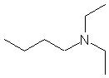
 |  | N-propyl-N-methyl-1-butanamine | 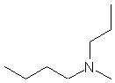
 |  | N-propyl-2-methyl-1-butanamine | 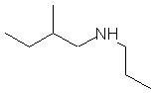
 |  | N-propyl-3-methyl-1-butanamine | 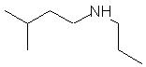
 |  | 2,2-diethyl-1-butanamine | 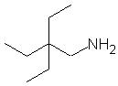
 |  | 2-ethyl-2,3-dimethyl-1-butanamine
 |  | 2-ethyl-3,3-dimethyl-1-butanamine | 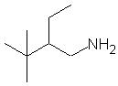
 |  | N-methyl-2-ethyl-2-methyl-1-butanamine | 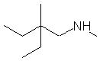
 |  | N-methyl-2-ethyl-3-methyl-1-butanamine | 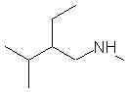
 |  | N,N-dimethyl-2-ethyl-1-butanamine | 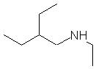
 |  | N-ethyl-2-ethyl-1-butanamine
 |  | N-methyl-2,3,3-trimethyl-2-butanamine | 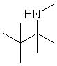
 |  | N,N-dimethyl-2,3-dimethyl-2-butanamine | 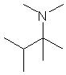
 |  | N,N-dimethyl-3,3-dimethyl-2-butanamine | 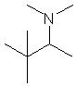
 |  | N,N-diethyl-2-butanamine | 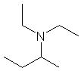
 |  | N-ethyl-N-methyl-2-methyl-2-butanamine | 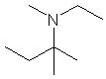
 |  | N-ethyl-N-methyl-3-methyl-2-butanamine | 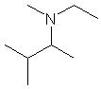
 |  | N-propyl-2-methyl-2-butanamine | 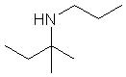
 |  | N-propyl-3-methyl-2-butanamine | 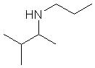
 |  | N-propyl-N-methyl-2-butanamine | 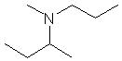
 | 3 | N-ethyl-N-propyl-1-propanamine | 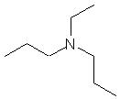
 |  | N-ethyl-N-propyl-2-propanamine | 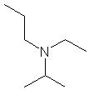
 |  | N,N-diethyl-2-methyl-1-propanamine | 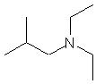
 |  | N,N-diethyl-2-methyl-2-propanamine | 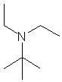
 |  | N-methyl-N-propyl-2-methyl-1-propanamine | 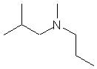
 |  | N-methyl-N-propyl-2-methyl-2-propanamine | 