CHE 101 – CH 20 – Alkynes

Total # Carbons | # C Main Chain | IUPAC Name | Linear Structure | Structural Formula
2 | 2 | ethyne
3 | 3 | 1-propyne | 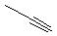
4 | 4 | 1-butyne | 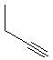
 |  | 2-butyne | 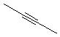
5 | 5 | 1-pentyne | 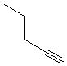
 |  | 2-pentyne | 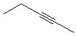
 | 4 | 3-methyl-1-pentyne | 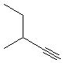
6 | 6 | 1-hexyne | 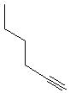
 |  | 2-hexyne | 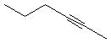
 |  | 3-hexyne | 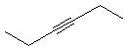
 | 5 | 3-methyl-1-pentyne
 |  | 4-methyl-1-pentyne | 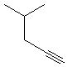
 |  | 4-methyl-2-pentyne | 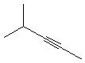
 | 4 | 3,3-dimethyl-1-butyne | 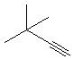
7 | 7 | 1-heptyne | 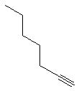
 |  | 2-heptyne | 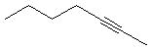
 |  | 3-heptyne | 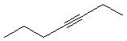
 | 6 | 3-methyl-1-hexyne | 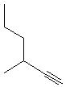
 |  | 4-methyl-2-hexyne | 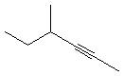
 |  | 5-methyl-2-hexyne | 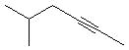
 |  | 2-methyl-3-hexyne | 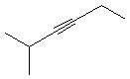
 |  | 4-methyl-2-hexyne
 | 5 | 3,3-dimethyl-1-pentyne | 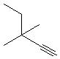
 |  | 3,4-dimethyl-1-pentyne | 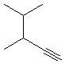
 |  | 4,4-dimethyl-1-pentyne | 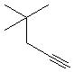
 |  | 3-ethyl-1-pentyne | 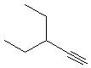
 |  | 4,4-dimethyl-2-pentyne | 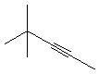
8 | 8 | 1-octyne | 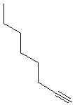
 |  | 2-octyne | 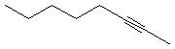
 |  | 3-octyne | 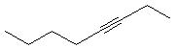
 |  | 4-octyne | 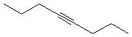
 | 7 | 3-methyl-1-heptyne | 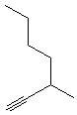
 |  | 4-methyl-1-heptyne | 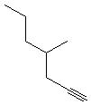
 |  | 5-methyl-1-heptyne | 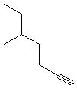
 |  | 6-methyl-1-heptyne | 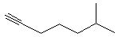
 |  | 4-methyl-2-heptyne | 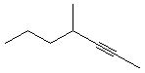
 |  | 5-methyl-2-heptyne | 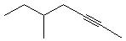
 |  | 6-methyl-2-heptyne | 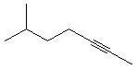
 |  | 2-methyl-3-heptyne | 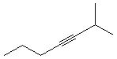
 |  | 5-methyl-3-heptyne | 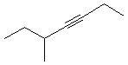
 |  | 6-methyl-3-heptyne | 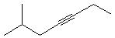
 | 6 | 3,3-dimethyl-1-hexyne | 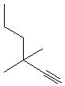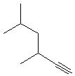
 |  | 3,4-dimethyl-1-hexyne | 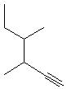
 |  | 3,5-dimethyl-1-hexyne
 |  | 3,3-dimethyl-1-hexyne
 |  | 4,4-dimethyl-1-hexyne | 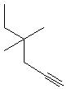
 |  | 4,5-dimethyl-1-hexyne | 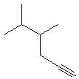
 |  | 5,5-dimethyl-1-hexyne | 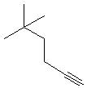
 |  | 3-ethyl-1-hexyne | 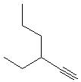
 |  | 4-ethyl-1-hexyne | 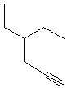
 |  | 4,4-dimethyl-2-hexyne | 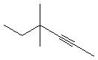
 |  | 4,5-dimethyl-2-hexyne | 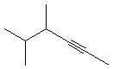
 |  | 5,5-dimethyl-2-hexyne | 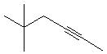
 |  | 4-ethyl-2-hexyne | 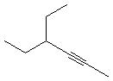
 |  | 2,2-dimethyl-3-hexyne | 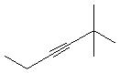
 |  | 2,4-dimethyl-3-hexyne | 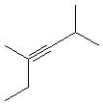
 | 5 | 3,3,4-trimethyl-1-pentyne | 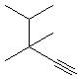
 |  | 3,4,4-trimethyl-1-pentyne | 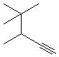
 |  | 3-ethyl-3-methyl-1-pentyne | 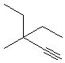
 |  | 3-ethyl-4-methyl-1-pentyne | 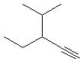
9 | 9 | 1-nonyne
 |  | 2-nonyne
 |  | 3-nonyne
 |  | 4-nonyne
 | 8 | 3-methyl-1-octyne | Start Here
 |  | 4-methyl-1-octyne
 |  | 5-methyl-1-octyne
 |  | 6-methyl-1-octyne
 |  | 7-methyl-1-octyne
 |  | 4-methyl-2-octyne
 |  | 5-methyl-2-octyne
 |  | 6-methyl-2-octyne
 |  | 7-methyl-2-octyne
 |  | 2-methyl-3-octyne
 |  | 5-methyl-3-octyne
 |  | 6-methyl-3-octyne
 |  | 7-methyl-3-octyne
 |  | 2-methyl-4-octyne
 |  | 3-methyl-4-octyne
 | 7 | 3,3-dimethyl-1-heptyne
 |  | 3,4-dimethyl-1-heptyne
 |  | 3,5-dimethyl-1-heptyne
 |  | 3,6-dimethyl-1-heptyne
 |  | 4,4-dimethyl-1-heptyne
 |  | 4,5-dimethyl-1-heptyne
 |  | 4,6-dimethyl-1-heptyne
 |  | 5,5-dimethyl-1-heptyne
 |  | 5,6-dimethyl-1-heptyne
 |  | 6,6-dimethyl-1-heptyne
 |  | 3-ethyl-1-heptyne
 |  | 4-ethyl-1-heptyne
 |  | 5-ethyl-1-heptyne
 |  | 4,4-dimethyl-2-heptyne
 |  | 4,5-dimethyl-2-heptyne
 |  | 4,6-dimethyl-2-heptyne
 |  | 5,5-dimethyl-2-heptyne
 |  | 5,6-dimethyl-2-heptyne
 |  | 6,6-dimethyl-2-heptyne
 |  | 4-ethyl-1-heptyne
 |  | 5-ethyl-1-heptyne
 | 6 | 3,3,4-trimethyl-1-hexyne
 |  | 3,4,5-trimethyl-1-hexyne
 |  | 3,3,5-trimethyl-1-hexyne
 |  | 4,4,5-trimethyl-1-hexyne
 |  | 4,5,5-trimethyl-1-hexyne
 |  | 3-ethyl-3-methyl-1-hexyne
 |  | 3-ethyl-4-methyl-1-hexyne
 |  | 3-ethyl-5-methyl-1-hexyne
 |  | 4-ethyl-3-methyl-1-hexyne
 |  | 4-ethyl-4-methyl-1-hexyne
 |  | 4-ethyl-5-methyl-1-hexyne
 |  | 3-propyl-1-hexyne
 |  | 4,4,5-trimethyl-2-hexyne
 |  | 4,5,5-trimethyl-2-hexyne
 |  | 4-ethyl-4-methyl-2-hexyne
 |  | 4-ethyl-5-methyl-2-hexyne
 |  | 2,2,5-trimethyl-3-hexyne
 | 5 | 3,3,4,4-tetramethyl-1-pentyne
 |  | 3,3-diethyl-1-pentyne
 |  | 3-ethyl-3,4-dimethyl-1-pentyne
 |  | 3-ethyl-4,4-dimethyl-1-pentyne
10 | 10 | 1-decyne
 |  | 2-decyne
 |  | 3-decyne
 |  | 4-decyne
 |  | 5-decyne
 | 9 | 3-methyl-1-nonyne
 |  | 4-methyl-1-nonyne
 |  | 5-methyl-1-nonyne
 |  | 6-methyl-1-nonyne
 |  | 7-methyl-1-nonyne
 |  | 8-methyl-1-nonyne
 |  | 4-methyl-2-nonyne
 |  | 5-methyl-2-nonyne
 |  | 6-methyl-2-nonyne
 |  | 7-methyl-2-nonyne
 |  | 8-methyl-2-nonyne
 |  | 2-methyl-3-nonyne
 |  | 5-methyl-3-nonyne
 |  | 6-methyl-3-nonyne
 |  | 7-methyl-3-nonyne
 |  | 8-methyl-3-nonyne
 |  | 2-methyl-4-nonyne
 |  | 3-methyl-4-nonyne
 |  | 6-methyl-4-nonyne
 |  | 7-methyl-4-nonyne
 |  | 8-methyl-4-nonyne
 | 8 | 3,3-dimethyl-1-octyne
 |  | 3,4-dimethyl-1-octyne
 |  | 3,5-dimethyl-1-octyne
 |  | 3,6-dimethyl-1-octyne
 |  | 3,7-dimethyl-1-octyne
 |  | 4,4-dimethyl-1-octyne
 |  | 4,5-dimethyl-1-octyne
 |  | 4,6-dimethyl-1-octyne
 |  | 4,7-dimethyl-1-octyne
 |  | 5,5-dimethyl-1-octyne
 |  | 5,6-dimethyl-1-octyne
 |  | 5,7-dimethyl-1-octyne
 |  | 6,6-dimethyl-1-octyne
 |  | 6,7-dimethyl-1-octyne
 |  | 7,7-dimethyl-1-octyne
 |  | 3-ethyl-1-octyne
 |  | 4-ethyl-1-octyne
 |  | 5-ethyl-1-octyne
 |  | 6-ethyl-1-octyne
 |  | 4,4-dimethyl-2-octyne
 |  | 4,5-dimethyl-2-octyne
 |  | 4,6-dimethyl-2-octyne
 |  | 4,7-dimethyl-2-octyne
 |  | 5,5-dimethyl-2-octyne
 |  | 5,6-dimethyl-2-octyne
 |  | 5,7-dimethyl-2-octyne
 |  | 6,6-dimethyl-2-octyne
 |  | 6,7-dimethyl-2-octyne
 |  | 7,7-dimethyl-2-octyne
 |  | 4-ethyl-2-octyne
 |  | 5-ethyl-2-octyne
 |  | 6-ethyl-2-octyne
 |  | 2,2-dimethyl-3-octyne
 |  | 2,5-dimethyl-3-octyne
 |  | 2,5-dimethyl-3-octyne
 |  | 2,6-dimethyl-3-octyne
 |  | 5,5-dimethyl-3-octyne
 |  | 5,6-dimethyl-3-octyne
 |  | 5,7-dimethyl-3-octyne
 |  | 6,6-dimethyl-3-octyne
 |  | 6,7-dimethyl-3-octyne
 |  | 7,7-dimethyl-3-octyne
 |  | 5-ethyl-3-octyne
 |  | 6-ethyl-3-octyne
 |  | 2,2-dimethyl-4-octyne
 |  | 2,3-dimethyl-4-octyne
 |  | 2,6-dimethyl-4-octyne
 |  | 2,7-dimethyl-4-octyne
 |  | 3,3-dimethyl-4-octyne
 |  | 3,6-dimethyl-4-octyne
 |  | 3,7-dimethyl-4-octyne
 |  | 3-ethyl-4-octyne
 | 7 | 3,3,4-trimethyl-1-heptyne
 |  | 3,3,5-trimethyl-1-heptyne
 |  | 3,3,6-trimethyl-1-heptyne
 |  | 3,3,4-trimethyl-1-heptyne
 |  | 3,4,4-trimethyl-1-heptyne
 |  | 3,3,4-trimethyl-1-heptyne
 |  | 3,4,5-trimethyl-1-heptyne
 |  | 3,4,6-trimethyl-1-heptyne
 |  | 4,4,5-trimethyl-1-heptyne
 |  | 4,4,6-trimethyl-1-heptyne
 |  | 4,5,6-trimethyl-1-heptyne
 |  | 5,5,6-trimethyl-1-heptyne
 |  | 3,5,5-trimethyl-1-heptyne
 |  | 3,6,6-trimethyl-1-heptyne
 |  | 4,5,5-trimethyl-1-heptyne
 |  | 4,6,6-trimethyl-1-heptyne
 |  | 5,6,6-trimethyl-1-heptyne
 |  | 3-ethyl-3-methyl-1-heptyne
 |  | 3-ethyl-4-methyl-1-heptyne
 |  | 3-ethyl-5-methyl-1-heptyne
 |  | 3-ethyl-6-methyl-1-heptyne
 |  | 4-ethyl-3-methyl-1-heptyne
 |  | 4-ethyl-4-methyl-1-heptyne
 |  | 4-ethyl-5-methyl-1-heptyne
 |  | 4-ethyl-6-methyl-1-heptyne
 |  | 5-ethyl-3-methyl-1-heptyne
 |  | 5-ethyl-4-methyl-1-heptyne
 |  | 5-ethyl-5-methyl-1-heptyne
 |  | 5-ethyl-6-methyl-1-heptyne
 |  | 3-propyl-1-heptyne
 |  | 4-propyl-1-heptyne
 |  | 4,4,5-trimethyl-2-heptyne
 |  | 4,4,6-trimethyl-2-heptyne
 |  | 4,5,5-trimethyl-2-heptyne
 |  | 4,6,6-trimethyl-2-heptyne
 |  | 5,5,6-trimethyl-2-heptyne
 |  | 5,6,6-trimethyl-2-heptyne
 |  | 4-ethyl-4-methyl-2-heptyne
 |  | 4-ethyl-5-methyl-2-heptyne
 |  | 4-ethyl-6-methyl-2-heptyne
 |  | 5-ethyl-4-methyl-2-heptyne
 |  | 5-ethyl-5-methyl-2-heptyne
 |  | 5-ethyl-6-methyl-2-heptyne
 |  | 4-propyl-2-heptyne
 |  | 2,2,5-trimethyl-3-heptyne
 |  | 2,2,6-trimethyl-3-heptyne
 |  | 2,5,5-trimethyl-3-heptyne
 |  | 2,5,6-trimethyl-3-heptyne
 |  | 2,6,6-trimethyl-3-heptyne
 |  | 5,5,6-trimethyl-3-heptyne
 |  | 5,6,6-trimethyl-3-heptyne
 |  | 5-ethyl-2-methyl-3-heptyne
 |  | 5-ethyl-5-methyl-3-heptyne
 |  | 5-ethyl-6-methyl-3-heptyne
 | 6 | 3,3,4,4-tetramethyl-1-hexyne
 |  | 3,3,5,5-tetramethyl-1-hexyne
 |  | 4,4,5,5-tetramethyl-1-hexyne
 |  | 3,3-diethyl-1-hexyne
 |  | 3,4-diethyl-1-hexyne
 |  | 4,4-diethyl-1-hexyne
 |  | 3-ethyl-3,4-dimethyl-1-hexyne
 |  | 3-ethyl-4,4-dimethyl-1-hexyne
 |  | 3-ethyl-4,5-dimethyl-1-hexyne
 |  | 3-ethyl-5,5-dimethyl-1-hexyne
 |  | 3-ethyl-3,5-dimethyl-1-hexyne
 |  | 4-ethyl-3,3-dimethyl-1-hexyne
 |  | 4-ethyl-3,4-dimethyl-1-hexyne
 |  | 4-ethyl-3,5-dimethyl-1-hexyne
 |  | 4-ethyl-5,5-dimethyl-1-hexyne
 |  | 4-ethyl-4,5-dimethyl-1-hexyne
 |  | 4,4,5,5-tetramethyl-2-hexyne
 |  | 4,4-diethyl-2-hexyne
 |  | 4-ethyl-4,5-dimetyl-2-hexyne
 |  | 4-ethyl-5,5-dimetyl-2-hexyne
 |  | 2,2,5,5-tetramethyl-3-hexyne
 | 5 | 3,3-diethyl-4-methyl-1-pentyne

