CHE 101 – CH 20 – Alkenes (~220)

Total # Carbons | # C Main Chain | IUPAC Name | Linear Structure | Structural Formula
2 | 2 | ethene
3 | 3 | propene
4 | 4 | 1-butene
 |  | 2-butene
 | 3 | 2-methyl-1-propene | 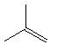
5 | 5 | 1-pentene | 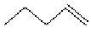
 |  | 2-pentene | 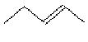
 | 4 | 2-methyl-1-butene | 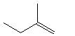
 |  | 3-methyl-1-butene | 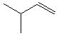
 |  | 2-methyl-2-butene | 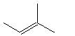
6 | 6 | 1-hexene
 |  | 2-hexene
 |  | 3-hexene
 | 5 | 2-methyl-1-pentene | 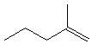
 |  | 3-methyl-1-pentene
 |  | 4-methyl-1-pentene | 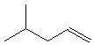
 |  | 2-methyl-2-pentene | 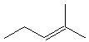
 |  | 3-methyl-2-pentene | 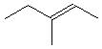
 |  | 4-methyl-2-pentene | 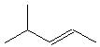
 | 4 | 3,3-dimethyl-1-butene | 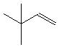
 |  | 2,3-dimethyl-2-butene | 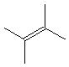
7 | 7 | 1-heptene
 |  | 2-heptene
 |  | 3-heptene
 | 6 | 2-methyl-1-hexene | 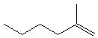
 |  | 3-methyl-1-hexene | 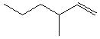
 |  | 4-methyl-1-hexene | 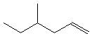
 |  | 5-methyl-1-hexene | 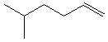
 |  | 2-methyl-2-hexene | 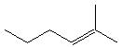
 |  | 3-methyl-2-hexene | 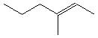
 |  | 4-methyl-2-hexene | 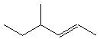
 |  | 5-methyl-2-hexene | 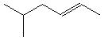
 |  | 2-methyl-3-hexene | 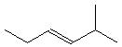
 |  | 3-methyl-3-hexene | 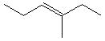
 | 5 | 2,3-dimethyl-1-pentene | 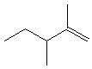
 |  | 2,4-dimethyl-1-pentene | 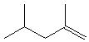
 |  | 3,4-dimethyl-1-pentene | 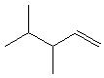
 |  | 3,3-dimethyl-1-pentene | 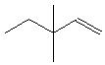
 |  | 4,4-dimethyl-1-pentene | 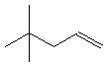
 |  | 2-ethyl-1-pentene | 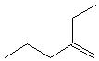
 |  | 3-ethyl-1-pentene | 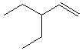
 |  | 2,3-dimethyl-2-pentene | 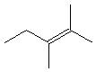
 |  | 2,4-dimethyl-2-pentene | 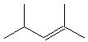
 |  | 3,4-dimethyl-2-pentene | 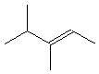
 |  | 4,4-dimethyl-2-pentene | 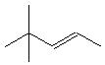
 |  | 3-ethyl-2-pentene | 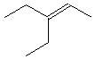
 | 4 | 2,3,3-trimethyl-1-butene | 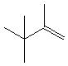
8 | 8 | 1-octene
 |  | 2-octene
 |  | 3-octene
 |  | 4-octene
 | 7 | 2-methyl-1-heptene | 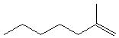
 |  | 3-methyl-1-heptene | 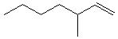
 |  | 4-methyl-1-heptene | 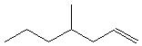
 |  | 5-methyl-1-heptene | 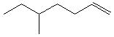
 |  | 6-methyl-1-heptene | 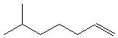
 |  | 2-methyl-2-heptene | 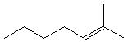
 |  | 3-methyl-2-heptene | 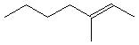
 |  | 4-methyl-2-heptene | 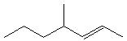
 |  | 5-methyl-2-heptene | 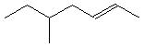
 |  | 6-methyl-2-heptene | 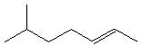
 |  | 2-methyl-3-heptene | 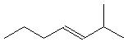
 |  | 3-methyl-3-heptene | 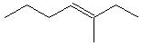
 |  | 4-methyl-3-heptene | 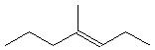
 |  | 5-methyl-3-heptene | 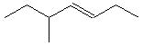
 |  | 6-methyl-3-heptene | 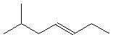
 | 6 | 2,3-dimethyl-1-hexene | 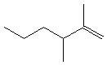
 |  | 2,4-dimethyl-1-hexene | 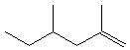
 |  | 2,5-dimethyl-1-hexene | 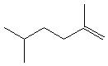
 |  | 3,3-dimethyl-1-hexene | 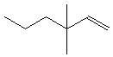
 |  | 4,4-dimethyl-1-hexene | 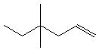
 |  | 5,5-dimethyl-1-hexene | 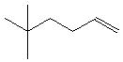
 |  | 3,4-dimethyl-1-hexene | 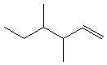
 |  | 3,5-dimethyl-1-hexene | 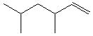
 |  | 4,5-dimethyl-1-hexene | 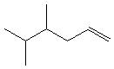
 |  | 2-ethyl-1-hexene | 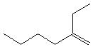
 |  | 3-ethyl-1-hexene | 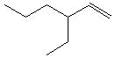
 |  | 4-ethyl-1-hexene | 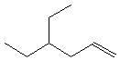
 |  | 2,3-dimethyl-2-hexene | 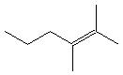
 |  | 2,4-dimethyl-2-hexene | 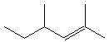
 |  | 2,5-dimethyl-2-hexene | 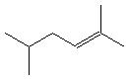
 |  | 3,4-dimethyl-2-hexene | 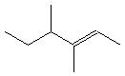
 |  | 3,5-dimethyl-2-hexene | 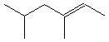
 |  | 4,4-dimethyl-2-hexene | 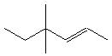
 |  | 4,5-dimethyl-2-hexene | 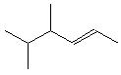
 |  | 5,5-dimethyl-2-hexene | 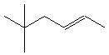
 |  | 3-ethyl-2-hexene | 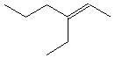
 |  | 4-ethyl-2-hexene | 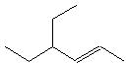
 |  | 2,3-dimethyl-3-hexene | 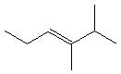
 | start | 2,4-dimethyl-3-hexene
 |  | 2,5-dimethyl-3-hexene
 |  | 3,4-dimethyl-3-hexene
 |  | 2,2-dimethyl-3-hexene
 |  | 2-ethyl-3-hexene
 | 5 | 2,3,3-trimethyl-1-pentene
 |  | 2,4,4-trimethyl-1-pentene
 |  | 2,3,4-trimethyl-1-pentene
 |  | 3,3,4-trimethyl-1-pentene
 |  | 3,4,4-trimethyl-1-pentene
 |  | 2-ethyl-3-methyl-1-pentene
 |  | 2-ethyl-4-methyl-1-pentene
 |  | 3-ethyl-2-methyl-1-pentene
 |  | 3-ethyl-3-methyl-1-pentene
 |  | 3-ethyl-4-methyl-1-pentene
 |  | 2-propyl-1-pentene
 |  | 2,3,4-trimethyl-2-pentene
 |  | 2,4,4-trimethyl-2-pentene
 |  | 3,4,4-trimethyl-2-pentene
 |  | 3-ethyl-2-methyl-2-pentene
 |  | 3-ethyl-4-methyl-2-pentene
9 | 9 | 1-nonene
 |  | 2-nonene
 |  | 3-nonene
 |  | 4-nonene
 | 8 | 2-methyl-1-octene
 |  | 3-methyl-1-octene
 |  | 4-methyl-1-octene
 |  | 5-methyl-1-octene
 |  | 6-methyl-1-octene
 |  | 7-methyl-1-octene
 |  | 2-methyl-2-octene
 |  | 3-methyl-2-octene
 |  | 4-methyl-2-octene
 |  | 5-methyl-2-octene
 |  | 6-methyl-2-octene
 |  | 7-methyl-2-octene
 |  | 2-methyl-3-octene
 |  | 3-methyl-3-octene
 |  | 4-methyl-3-octene
 |  | 5-methyl-3-octene
 |  | 6-methyl-3-octene
 |  | 7-methyl-3-octene
 |  | 2-methyl-4-octene
 |  | 3-methyl-4-octene
 |  | 4-methyl-4-octene
 |  | 5-methyl-4-octene
 |  | 6-methyl-4-octene
 |  | 7-methyl-4-octene
 | 7 | 2,3-dimethyl-1-heptene
 |  | 2,4-dimethyl-1-heptene
 |  | 2,5-dimethyl-1-heptene
 |  | 2,6-dimethyl-1-heptene
 |  | 3,3-dimethyl-1-heptene
 |  | 3,4-dimethyl-1-heptene
 |  | 3,5-dimethyl-1-heptene
 |  | 3,6-dimethyl-1-heptene
 |  | 4,4-dimethyl-1-heptene
 |  | 4,5-dimethyl-1-heptene
 |  | 4,6-dimethyl-1-heptene
 |  | 5,5-dimethyl-1-heptene
 |  | 5,6-dimethyl-1-heptene
 |  | 6,6-dimethyl-1-heptene
 |  | 2-ethyl-1-heptene
 |  | 3-ethyl-1-heptene
 |  | 4-ethyl-1-heptene
 |  | 5-ethyl-1-heptene
 |  | 2,3-dimethyl-2-heptene
 |  | 2,4-dimethyl-2-heptene
 |  | 2,5-dimethyl-2-heptene
 |  | 2,6-dimethyl-2-heptene
 |  | 3,4-dimethyl-2-heptene
 |  | 3,5-dimethyl-2-heptene
 |  | 3,6-dimethyl-2-heptene
 |  | 4,4-dimethyl-2-heptene
 |  | 4,5-dimethyl-2-heptene
 |  | 4,6-dimethyl-2-heptene
 |  | 5,5-dimethyl-2-heptene
 |  | 5,6-dimethyl-2-heptene
 |  | 6,6-dimethyl-2-heptene
 |  | 2-ethyl-2-heptene
 |  | 3-ethyl-2-heptene
 |  | 4-ethyl-2-heptene
 |  | 5-ethyl-2-heptene
 |  | 2,2-dimethyl-3-heptene
 |  | 2,3-dimethyl-3-heptene
 |  | 2,4-dimethyl-3-heptene
 |  | 2,5-dimethyl-3-heptene
 |  | 2,6-dimethyl-3-heptene
 |  | 3,4-dimethyl-3-heptene
 |  | 3,5-dimethyl-3-heptene
 |  | 3,6-dimethyl-3-heptene
 |  | 3-ethyl-3-heptene
 |  | 4-ethyl-3-heptene
 |  | 5-ethyl-3-heptene
 | 6 | 2,3,3-trimethyl-1-hexene
 |  | 2,4,4-trimethyl-1-hexene
 |  | 2,5,5-trimethyl-1-hexene
 |  | 2,3,4-trimethyl-1-hexene
 |  | 2,3,5-trimethyl-1-hexene
 |  | 3,4,5-trimethyl-1-hexene
 |  | 4,4,5-trimethyl-1-hexene
 |  | 4,5,5-trimethyl-1-hexene
 |  | 2-ethyl-3-methyl-1-hexene
 |  | 2-ethyl-4-methyl-1-hexene
 |  | 2-ethyl-5-methyl-1-hexene
 |  | 3-ethyl-2-methyl-1-hexene
 |  | 3-ethyl-3-methyl-1-hexene
 |  | 3-ethyl-4-methyl-1-hexene
 |  | 3-ethyl-5-methyl-1-hexene
 |  | 4-ethyl-2-methyl-1-hexene
 |  | 4-ethyl-3-methyl-1-hexene
 |  | 4-ethyl-4-methyl-1-hexene
 |  | 4-ethyl-5-methyl-1-hexene
 |  | 2-propyl-1-hexene
 |  | 3-propyl-1-hexene
 |  | 2,3,4-trimethyl-2-hexene
 |  | 2,3,5-trimethyl-2-hexene
 |  | 2,4,4-trimethyl-2-hexene
 |  | 2,4,5-trimethyl-2-hexene
 |  | 2,5,5-trimethyl-2-hexene
 |  | 3,4,4-trimethyl-2-hexene
 |  | 3,4,5-trimethyl-2-hexene
 |  | 3,5,5-trimethyl-2-hexene
 |  | 4,4,5-trimethyl-2-hexene
 |  | 4,5,5-trimethyl-2-hexene
 |  | 2-ethyl-3-methyl-2-hexene
 |  | 2-ethyl-3-methyl-2-hexene
 |  | 2-ethyl-4-methyl-2-hexene
 |  | 2-ethyl-5-methyl-2-hexene
 |  | 3-ethyl-2-methyl-2-hexene
 |  | 3-ethyl-4-methyl-2-hexene
 |  | 3-ethyl-5-methyl-2-hexene
 |  | 4-ethyl-4-methyl-2-hexene
 |  | 4-ethyl-5-methyl-2-hexene
 |  | 2-propyl-2-hexene
 |  | 3-propyl-2-hexene
 |  | 2,2,3-trimethyl-3-hexene
 |  | 2,2,4-trimethyl-3-hexene
 |  | 2,2,5-trimethyl-3-hexene
 |  | 2,3,4-trimethyl-3-hexene
 |  | 2,2,5-trimethyl-3-hexene
 |  | 3-ethyl-2-methyl-3-hexene
 |  | 3-ethyl-4-methyl-3-hexene
 |  | 3-ethyl-5-methyl-3-hexene
 | 5 | 2,3,3,4-tetramethyl-1-pentene
 |  | 2,3,4,4-tetramethyl-1-pentene
 |  | 3,3,4,4-tetramethyl-1-pentene
 |  | 2-ethyl-3,3-dimethyl-1-pentene
 |  | 2-ethyl-3,4-dimethyl-1-pentene
 |  | 2-ethyl-4,4-dimethyl-1-pentene
 |  | 3-ethyl-2,3-dimethyl-1-pentene
 |  | 3-ethyl-2,4-dimethyl-1-pentene
 |  | 3-ethyl-3,4-dimethyl-1-pentene
 |  | 3-ethyl-4,4-dimethyl-1-pentene
 |  | 2-propyl-3-methyl-1-pentene
 |  | 2-propyl-4-methyl-1-pentene
 |  | 2,3,4,4-tetramethyl-2-pentene
 |  | 2-ethyl-3,4-dimethyl-2-pentene
 |  | 2-ethyl-4,4-dimethyl-2-pentene
 |  | 3-ethyl-2,4-dimethyl-2-pentene
 |  | 3-ethyl-4,4-dimethyl-2-pentene

