CHE 102 – CH 23 – Aldehydes

Total # Carbons | # C Main Chain | IUPAC Name | Linear Structure | Structural Formula
1 |  | methanal
2 |  | ethanal
3 | 3 | propanal
4 | 4 | butanal | 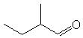
4 | 3 | 2-methylpropanal | 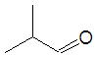
5 | 5 | pentanal
 | 4 | 2-methylbutanal
 |  | 3-methylbutanal | 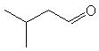
 | 3 | 2,2-dimethylpropanal | 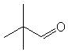
6 | 6 | hexanal
 | 5 | 2-methylpentanal | 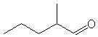
 |  | 3-methylpentanal | 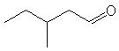
 |  | 4-methylpentanal | 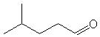
 | 4 | 2,2-dimethylbutanal | 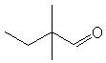
 |  | 2,3-dimethylbutanal | 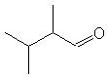
 |  | 3,3-dimethylbutanal | 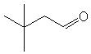
 |  | 2-ethylbutanal | 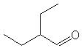
7 | 7 | heptanal
 | 6 | 2-methylhexanal | 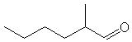
 |  | 3-methylhexanal | 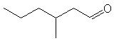
 |  | 4-methylhexanal | 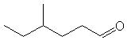
 |  | 5-methylhexanal | 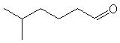
 | 5 | 2,2-dimethylpentanal | 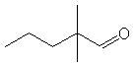
 |  | 2,3-dimethylpentanal | 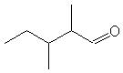
 |  | 2,4-dimethylpentanal | 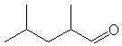
 |  | 3,3-dimethylpentanal | 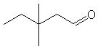
 |  | 3,4-dimethylpentanal | 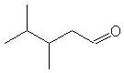
 |  | 4,4-dimethylpentanal | 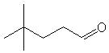
 |  | 2-ethylpentanal | 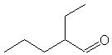
 |  | 3-ethylpentanal | 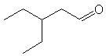
 | 4 | 2,2,3-trimethylbutanal | 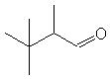
 |  | 2,3,3-trimethylbutanal | 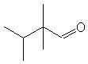
 |  | 2-ethyl-3-methylbutanal | 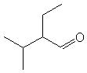
8 | 8 | octanal
 | 7 | 2-methylheptanal | 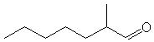
 |  | 3-methylheptanal | 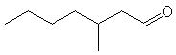
 |  | 4-methylheptanal | 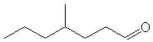
 |  | 5-methylheptanal | 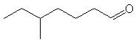
 |  | 6-methylheptanal | 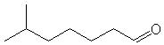
 | 6 | 2,2-dimethylhexanal | 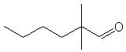
 |  | 2,3-dimethylhexanal | 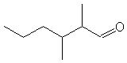
 |  | 2,4-dimethylhexanal | 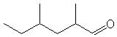
 |  | 2,5-dimethylhexanal | 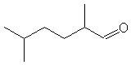
 |  | 3,3-dimethylhexanal | 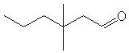
 |  | 3,4-dimethylhexanal | 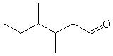
 |  | 3,5-dimethylhexanal | 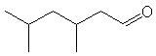
 |  | 4,4-dimethylhexanal | 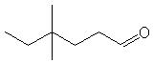
 |  | 4,5-dimethylhexanal | 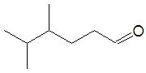
 |  | 5,5-dimethylhexanal | 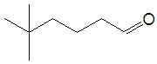
 |  | 2-ethylhexanal | 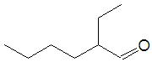
 |  | 3-ethylhexanal | 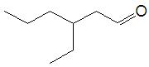
 |  | 4-ethylhexanal | 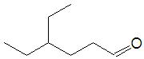
 | 5 | 2,2,3-trimethylpentanal | 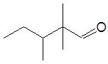
 |  | 2,2,4-trimethylpentanal | 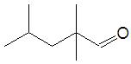
 |  | 2,3,3-trimethylpentanal | 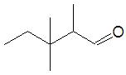
 |  | 2,3,4-trimethylpentanal | 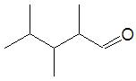
 |  | 2,4,4-trimethylpentanal | 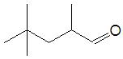
 |  | 3,3,4-trimethylpentanal | 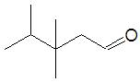
 |  | 3,4,4-trimethylpentanal | 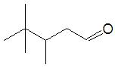
 |  | 2-ethyl-2-methylpentanal | 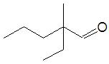
 |  | 2-ethyl-3-methylpentanal | 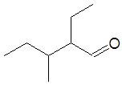
 |  | 2-ethyl-4-methylpentanal | 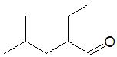
 |  | 3-ethyl-2-methylpentanal | 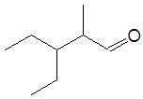
 |  | 3-ethyl-3-methylpentanal | 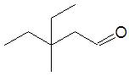
 |  | 3-ethyl-4-methylpentanal | 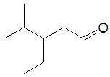
 |  | 2-propylpentanal | 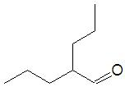
 | 4 | 2,2,3,3-tetramethylbutanal | 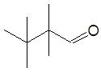
 |  | 2,2-diethylbutanal | 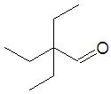
9 | 9 | nonal
 | 8 | 2-methyloctanal
 |  | 3-methyloctanal
 |  | 4-methyloctanal
 |  | 5-methyloctanal
 |  | 6-methyloctanal
 |  | 7-methyloctanal
 | 7 | 2,2-dimethylheptanal
 |  | 2,3-dimethylheptanal
 |  | 2,4-dimethylheptanal
 |  | 2,5-dimethylheptanal
 |  | 2,6-dimethylheptanal
 |  | 3,3-dimethylheptanal
 |  | 3,4-dimethylheptanal
 |  | 3,5-dimethylheptanal
 |  | 3,6-dimethylheptanal
 |  | 4,4-dimethylheptanal
 |  | 4,5-dimethylheptanal
 |  | 4,6-dimethylheptanal
 |  | 5,5-dimethylheptanal
 |  | 5,6-dimethylheptanal
 |  | 6,6-dimethylheptanal
 |  | 2-ethylheptanal
 |  | 3-ethylheptanal
 |  | 4-ethylheptanal
 |  | 5-ethylheptanal
 | 6 | 2,2,3-trimethylhexanal
 |  | 2,2,4-trimethylhexanal
 |  | 2,2,5-trimethylhexanal
 |  | 2,3,3-trimethylhexanal
 |  | 2,3,4-trimethylhexanal
 |  | 2,3,5-trimethylhexanal
 |  | 2,4,4-trimethylhexanal
 |  | 2,4,5-trimethylhexanal
 |  | 2,5,5-trimethylhexanal
 |  | 3,3,4-trimethylhexanal
 |  | 3,3,5-trimethylhexanal
 |  | 3,4,4-trimethylhexanal
 |  | 3,4,5-trimethylhexanal
 |  | 4,4,5-trimethylhexanal
 |  | 4,5,5-trimethylhexanal
 |  | 2-ethyl-2-methylhexanal
 |  | 2-ethyl-3-methylhexanal
 |  | 2-ethyl-4-methylhexanal
 |  | 2-ethyl-5-methylhexanal
 |  | 3-ethyl-2-methylhexanal
 |  | 3-ethyl-3-methylhexanal
 |  | 3-ethyl-4-methylhexanal
 |  | 3-ethyl-5-methylhexanal
 |  | 4-ethyl-2-methylhexanal
 |  | 4-ethyl-3-methylhexanal
 |  | 4-ethyl-4-methylhexanal
 |  | 4-ethyl-5-methylhexanal
 |  | 2-propylhexanal
 |  | 3-propyhexanal
 | 5 | 2,2,3,3-tetramethylpentanal
 |  | 2,2,3,4-tetramethylpentanal
 |  | 2,2,4,4-tetramethylpentanal
 |  | 2,3,3,4-tetramethylpentanal
 |  | 2,3,4,4-tetramethylpentanal
 |  | 3,3,4,4-tetramethylpentanal
 |  | 2,2-diethylpentanal
 |  | 2,3-diethylpentanal
 |  | 3,3-diethylpentanal
 |  | 2-ethyl-2,3-dimethylpentanal
 |  | 2-ethyl-2,4-dimethylpentanal
 |  | 2-ethyl-3,3-dimethylpentanal
 |  | 2-ethyl-3,4-dimethylpentanal
 |  | 2-ethyl-4,4-dimethylpentanal
 |  | 3-ethyl-2,2-dimethylpentanal
 |  | 3-ethyl-2,3-dimethylpentanal
 |  | 3-ethyl-2,4-dimethylpentanal
 |  | 3-ethyl-3,4-dimethylpentanal
 |  | 3-ethyl-4,4-dimethylpentanal
 |  | 2-propyl-2-methylpentanal
 |  | 2-propyl-3-methylpentanal
 |  | 2-propyl-4-methylpentanal
 | 4 | 2,2-diethyl-3-methylbutanal

