CHE 101 – CH 22 – Alcohols

Total # Carbons | # C Main Chain | IUPAC Name | Linear Structure | Structural Formula
1 | 1 | methanol | 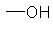
2 | 2 | ethanol | 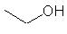
3 | 3 | 1-propanol | 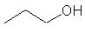
 |  | 2-propanol | 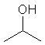
4 | 4 | 1-butanol | 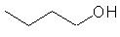
 |  | 2-butanol | 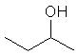
 | 3 | 2-methyl-1-propanol | 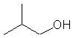
 |  | 2-methyl-2-propanol | 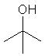
5 | 5 | 1-pentanol | 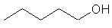
 |  | 2-pentanol | 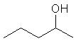
 |  | 3-pentanol | 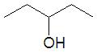
 | 4 | 2-methyl-1-butanol | 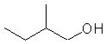
 |  | 2-methyl-2-butanol | 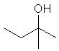
 |  | 3-methyl-2-butanol | 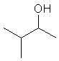
 | 3 | 2,2-dimethyl-1-propanol | 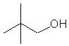
6 | 6 | 1-hexanol | 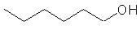
 |  | 2-hexanol | 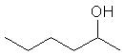
 |  | 3-hexanol | 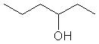
 | 5 | 2-methyl-1-pentanol | 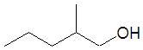
 |  | 2-methyl-2-pentanol | 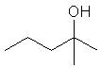
 |  | 2-methyl-3-pentanol | 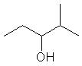
 |  | 4-methyl-2-pentanol | 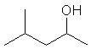
 |  | 3-methyl-1-pentanol | 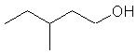
 |  | 3-methyl-2-pentanol | 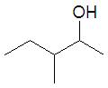
 |  | 3-methyl-3-pentanol | 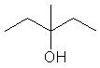
 | 4 | 2,2-dimethyl-1-butanol | 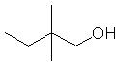
 |  | 3,3-dimethyl-2-butanol | 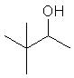
 |  | 3,3-dimethyl-1-butanol | 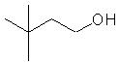
 |  | 2-ethyl-1-butanol | 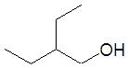
7 | 7 | 1-heptanol | 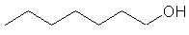
 |  | 2-heptanol | 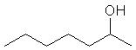
 |  | 3-heptanol | 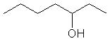
 |  | 4-heptanol | 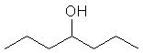
 | 6 | 2-methyl-1-hexanol | 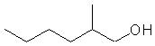
 |  | 3-methyl-1-hexanol | 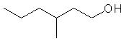
 |  | 4-methyl-1-hexanol | 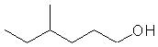
 |  | 5-methyl-1-hexanol | 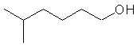
 |  | 2-methyl-2-hexanol | 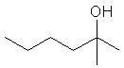
 |  | 3-methyl-2-hexanol | 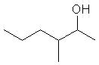
 |  | 4-methyl-2-hexanol | 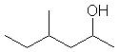
 |  | 5-methyl-2-hexanol | 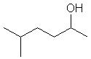
 |  | 2-methyl-3-hexanol | 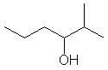
 |  | 3-methyl-3-hexanol | 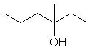
 |  | 4-methyl-3-hexanol | 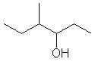
 |  | 5-methyl-3-hexanol | 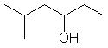
 | 5 | 2,2-dimethyl-1-pentanol | 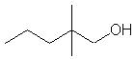
 |  | 2,3-dimethyl-1-pentanol | 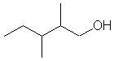
 |  | 2,4-dimethyl-1-pentanol | 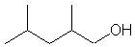
 |  | 3,3-dimethyl-1-pentanol | 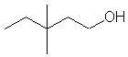
 |  | 3,4-dimethyl-1-pentanol | 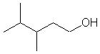
 |  | 4,4-dimethyl-1-pentanol | 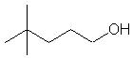
 |  | 2-ethyl-1-pentanol | 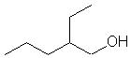
 |  | 3-ethyl-1-pentanol | 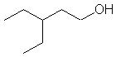
 |  | 2,3-dimethyl-2-pentanol | 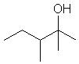
 |  | 2,4-dimethyl-2-pentanol | 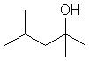
 |  | 3,3-dimethyl-2-pentanol | 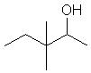
 |  | 3,4-dimethyl-2-pentanol | 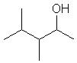
 |  | 4,4-dimethyl-2-pentanol | 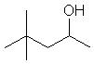
 |  | 3-ethyl-2-pentanol | 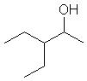
 |  | 2,2-dimethyl-3-pentanol | 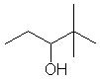
 |  | 2,3-dimethyl-3-pentanol | 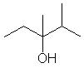
 |  | 2,4-dimethyl-3-pentanol | 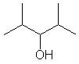
 |  | 3-ethyl-3-pentanol | 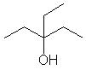
 | 4 | 2,2,3-trimethyl-1-butanol | 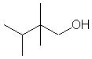
 |  | 2,3,3-trimethyl-1-butanol | 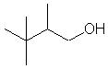
 |  | 2,3,3-trimethyl-2-butanol | 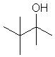
 |  | 2-ethyl-2-methyl-1-butanol | 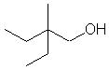
 |  | 2-ethyl-3-methyl-1-butanol | 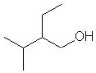
8 | 8 | 1-octanol
 |  | 2-octanol
 |  | 3-octanol
 |  | 4-octanol
 | 7 | 2-methyl-1-heptanol
 |  | 3-methyl-1-heptanol
 |  | 4-methyl-1-heptanol
 |  | 5-methyl-1-heptanol
 |  | 6-methyl-1-heptanol
 |  | 2-methyl-2-heptanol
 |  | 3-methyl-2-heptanol
 |  | 4-methyl-2-heptanol
 |  | 5-methyl-2-heptanol
 |  | 6-methyl-2-heptanol
 |  | 2-methyl-3-heptanol
 |  | 3-methyl-3-heptanol
 |  | 4-methyl-3-heptanol
 |  | 5-methyl-3-heptanol
 |  | 6-methyl-3-heptanol
 |  | 2-methyl-4-heptanol
 |  | 3-methyl-4-heptanol
 |  | 4-methyl-4-heptanol
 | 6 | 2,2-dimethyl-1-hexanol
 |  | 2,3-dimethyl-1-hexanol
 |  | 2,4-dimethyl-1-hexanol
 |  | 2,5-dimethyl-1-hexanol
 |  | 3,3-dimethyl-1-hexanol
 |  | 3,4-dimethyl-1-hexanol
 |  | 3,5-dimethyl-1-hexanol
 |  | 4,4-dimethyl-1-hexanol
 |  | 4,5-dimethyl-1-hexanol
 |  | 5,5-dimethyl-1-hexanol
 |  | 2-ethyl-1-hexanol
 |  | 3-ethyl-1-hexanol
 |  | 4-ethyl-1-hexanol
 |  | 2,3-dimethyl-2-hexanol
 |  | 2,4-dimethyl-2-hexanol
 |  | 2,5-dimethyl-2-hexanol
 |  | 3,3-dimethyl-2-hexanol
 |  | 3,4-dimethyl-2-hexanol
 |  | 3,5-dimethyl-2-hexanol
 |  | 4,4-dimethyl-2-hexanol
 |  | 4,5-dimethyl-2-hexanol
 |  | 5,5-dimethyl-2-hexanol
 |  | 2-ethyl-2-hexanol
 |  | 3-ethyl-2-hexanol
 |  | 4-ethyl-2-hexanol
 |  | 2,2-dimethyl-3-hexanol
 |  | 2,3-dimethyl-3-hexanol
 |  | 2,4-dimethyl-3-hexanol
 |  | 2,5-dimethyl-3-hexanol
 |  | 3,4-dimethyl-3-hexanol
 |  | 3,5-dimethyl-3-hexanol
 |  | 4,4-dimethyl-3-hexanol
 |  | 4,5-dimethyl-3-hexanol
 |  | 5,5-dimethyl-3-hexanol
 |  | 2-ethyl-1-hexanol
 |  | 3-ethyl-1-hexanol
 |  | 4-ethyl-1-hexanol
 | 5 | 2,2,3-trimethyl-1-pentanol
 |  | 2,2,4-trimethyl-1-pentanol
 |  | 2,3,4-trimethyl-1-pentanol
 |  | 2,4,4-trimethyl-1-pentanol
 |  | 3,3,4-trimethyl-1-pentanol
 |  | 3,4,4-trimethyl-1-pentanol
 |  | 2-ethyl-2-methyl-1-pentanol
 |  | 2-ethyl-3-methyl-1-pentanol
 |  | 2-ethyl-4-methyl-1-pentanol
 |  | 3-ethyl-2-methyl-1-pentanol
 |  | 3-ethyl-3-methyl-1-pentanol
 |  | 3-ethyl-4-methyl-1-pentanol
 |  | 2-propyl-1-pentanol
 |  | 2,3,3-trimethyl-2-pentanol
 |  | 2,3,4-trimethyl-2-pentanol
 |  | 2,4,4-trimethyl-2-pentanol
 |  | 3,3,4-trimethyl-2-pentanol
 |  | 3,4,4-trimethyl-2-pentanol
 |  | 2-ethyl-3-methyl-2-pentanol
 |  | 2-ethyl-4-methyl-2-pentanol
 |  | 3-ethyl-2-methyl-2-pentanol
 |  | 3-ethyl-3-methyl-2-pentanol
 |  | 3-ethyl-4-methyl-2-pentanol
 |  | 2-propyl-2-pentanol
 | 4 | 2,2,3,3-tetramethyl-1-butanol
 |  | 2-ethyl-3,3-dimethyl-2-butanol
9 | 9 | 1-nonol
 |  | 2-nonol
 |  | 3-nonol
 |  | 4-nonol
 |  | 5-nonol
 | 8 | 2-methyl-1-octanol
 |  | 3-methyl-1-octanol
 |  | 4-methyl-1-octanol
 |  | 5-methyl-1-octanol
 |  | 6-methyl-1-octanol
 |  | 7-methyl-1-octanol
 |  | 2-methyl-2-octanol
 |  | 3-methyl-2-octanol
 |  | 4-methyl-2-octanol
 |  | 5-methyl-2-octanol
 |  | 6-methyl-2-octanol
 |  | 7-methyl-2-octanol
 |  | 2-methyl-3-octanol
 |  | 3-methyl-3-octanol
 |  | 4-methyl-3-octanol
 |  | 5-methyl-3-octanol
 |  | 6-methyl-3-octanol
 |  | 7-methyl-3-octanol
 |  | 2-methyl-4-octanol
 |  | 3-methyl-4-octanol
 |  | 4-methyl-4-octanol
 | 7 | 2,2-dimethyl-1-heptanol
 |  | 2,3-dimethyl-1-heptanol
 |  | 2,4-dimethyl-1-heptanol
 |  | 2,5-dimethyl-1-heptanol
 |  | 2,6-dimethyl-1-heptanol
 |  | 3,3-dimethyl-1-heptanol
 |  | 3,4-dimethyl-1-heptanol
 |  | 3,5-dimethyl-1-heptanol
 |  | 3,6-dimethyl-1-heptanol
 |  | 4,4-dimethyl-1-heptanol
 |  | 4,5-dimethyl-1-heptanol
 |  | 4,6-dimethyl-1-heptanol
 |  | 5,5-dimethyl-1-heptanol
 |  | 5,6-dimethyl-1-heptanol
 |  | 6,6-dimethyl-1-heptanol
 |  | 2-ethyl-1-heptanol
 |  | 3-ethyl-1-heptanol
 |  | 4-ethyl-1-heptanol
 |  | 5-ethyl-1-heptanol
 |  | 2,3-dimethyl-2-heptanol
 |  | 2,4-dimethyl-2-heptanol
 |  | 2,5-dimethyl-2-heptanol
 |  | 2,6-dimethyl-2-heptanol
 |  | 3,3-dimethyl-2-heptanol
 |  | 3,4-dimethyl-2-heptanol
 |  | 3,5-dimethyl-2-heptanol
 |  | 3,6-dimethyl-2-heptanol
 |  | 4,4-dimethyl-2-heptanol
 |  | 4,5-dimethyl-2-heptanol
 |  | 4,6-dimethyl-2-heptanol
 |  | 5,5-dimethyl-2-heptanol
 |  | 5,6-dimethyl-2-heptanol
 |  | 6,6-dimethyl-2-heptanol
 |  | 2-ethyl-2-heptanol
 |  | 3-ethyl-2-heptanol
 |  | 4-ethyl-2-heptanol
 |  | 5-ethyl-2-heptanol
 |  | 2,2-dimethyl-3-heptanol
 |  | 2,3-dimethyl-3-heptanol
 |  | 2,4-dimethyl-3-heptanol
 |  | 2,5-dimethyl-3-heptanol
 |  | 2,6-dimethyl-3-heptanol
 |  | 3,4-dimethyl-3-heptanol
 |  | 3,5-dimethyl-3-heptanol
 |  | 3,6-dimethyl-3-heptanol
 |  | 4,4-dimethyl-3-heptanol
 |  | 4,5-dimethyl-3-heptanol
 |  | 4,6-dimethyl-3-heptanol
 |  | 5,5-dimethyl-3-heptanol
 |  | 5,6-dimethyl-3-heptanol
 |  | 6,6-dimethyl-3-heptanol
 |  | 3-ethyl-3-heptanol
 |  | 4-ethyl-3-heptanol
 |  | 5-ethyl-3-heptanol
 |  | 2,2-dimethyl-4-heptanol
 |  | 2,3-dimethyl-4-heptanol
 |  | 2,4-dimethyl-4-heptanol
 |  | 3,3-dimethyl-4-heptanol
 |  | 3,4-dimethyl-4-heptanol
 |  | 3-ethyl-4-heptanol
 |  | 4-ethyl-4-heptanol
 | 6 | 2,2,3-trimethyl-1-hexanol
 |  | 2,2,4-trimethyl-1-hexanol
 |  | 2,2,5-trimethyl-1-hexanol
 |  | 2,3,3-trimethyl-1-hexanol
 |  | 2,3,3-trimethyl-1-hexanol
 |  | 2,3,4-trimethyl-1-hexanol
 |  | 2,3,5-trimethyl-1-hexanol
 |  | 2,4,4-trimethyl-1-hexanol
 |  | 2,5,5-trimethyl-1-hexanol
 |  | 3,3,4-trimethyl-1-hexanol
 |  | 3,3,5-trimethyl-1-hexanol
 |  | 3,4,4-trimethyl-1-hexanol
 |  | 3,5,5-trimethyl-1-hexanol
 |  | 4,4,5-trimethyl-1-hexanol
 |  | 4,5,5-trimethyl-1-hexanol
 |  | 2-ethyl-2-methyl-1-hexanol
 |  | 2-ethyl-3-methyl-1-hexanol
 |  | 2-ethyl-4-methyl-1-hexanol
 |  | 2-ethyl-5-methyl-1-hexanol
 |  | 3-ethyl-2-methyl-1-hexanol
 |  | 3-ethyl-3-methyl-1-hexanol
 |  | 3-ethyl-4-methyl-1-hexanol
 |  | 3-ethyl-5-methyl-1-hexanol
 |  | 4-ethyl-2-methyl-1-hexanol
 |  | 4-ethyl-3-methyl-1-hexanol
 |  | 4-ethyl-4-methyl-1-hexanol
 |  | 4-ethyl-5-methyl-1-hexanol
 |  | 2-propyl-1-hexanol
 |  | 2-propyl-1-hexanol
 |  | 2,3,3-trimethyl-2-hexanol
 |  | 2,3,3-trimethyl-2-hexanol
 |  | 2,3,4-trimethyl-2-hexanol
 |  | 2,3,5-trimethyl-2-hexanol
 |  | 2,4,4-trimethyl-2-hexanol
 |  | 2,5,5-trimethyl-2-hexanol
 |  | 3,3,4-trimethyl-2-hexanol
 |  | 3,3,5-trimethyl-2-hexanol
 |  | 3,4,4-trimethyl-2-hexanol
 |  | 3,5,5-trimethyl-2-hexanol
 |  | 4,4,5-trimethyl-2-hexanol
 |  | 4,5,5-trimethyl-2-hexanol
 |  | 3-ethyl-2-methyl-2-hexanol
 |  | 3-ethyl-3-methyl-2-hexanol
 |  | 3-ethyl-4-methyl-2-hexanol
 |  | 3-ethyl-5-methyl-2-hexanol
 |  | 4-ethyl-2-methyl-2-hexanol
 |  | 4-ethyl-3-methyl-2-hexanol
 |  | 4-ethyl-4-methyl-2-hexanol
 |  | 4-ethyl-5-methyl-2-hexanol
 |  | 2-propyl-2-hexanol
 |  | 2,2,3-trimethyl-3-hexanol
 |  | 2,2,4-trimethyl-3-hexanol
 |  | 2,2,5-trimethyl-3-hexanol
 |  | 2,3,3-trimethyl-3-hexanol
 |  | 2,3,3-trimethyl-3-hexanol
 |  | 2,3,4-trimethyl-3-hexanol
 |  | 2,3,5-trimethyl-3-hexanol
 |  | 2,4,4-trimethyl-3-hexanol
 |  | 2,5,5-trimethyl-3-hexanol
 |  | 3,4,4-trimethyl-3-hexanol
 |  | 3,5,5-trimethyl-3-hexanol
 |  | 4,4,5-trimethyl-3-hexanol
 |  | 4,5,5-trimethyl-3-hexanol
 |  | 3-ethyl-2-methyl-3-hexanol
 |  | 3-ethyl-4-methyl-3-hexanol
 |  | 3-ethyl-5-methyl-3-hexanol
 |  | 4-ethyl-2-methyl-3-hexanol
 |  | 4-ethyl-3-methyl-3-hexanol
 |  | 4-ethyl-4-methyl-3-hexanol
 |  | 4-ethyl-5-methyl-3-hexanol
 |  | 3-propyl-3-hexanol
 | 5 | 2,2,3,3-tetramethyl-1-pentanol
 |  | 2,2,3,4-tetramethyl-1-pentanol
 |  | 2,2,4,4-tetramethyl-1-pentanol
 |  | 2,3,3,4-tetramethyl-1-pentanol
 |  | 3,3,4,4-tetramethyl-1-pentanol
 |  | 2,2-diethyl-1-pentanol
 |  | 2,3-diethyl-1-pentanol
 |  | 3,3-diethyl-1-pentanol
 |  | 2-ethyl-2,3-dimethyl-1-pentanol
 |  | 2-ethyl-2,4-dimethyl-1-pentanol
 |  | 2-ethyl-3,3-dimethyl-1-pentanol
 |  | 2-ethyl-3,4-dimethyl-1-pentanol
 |  | 2-ethyl-4,4-dimethyl-1-pentanol
 |  | 3-ethyl-2,2-dimethyl-1-pentanol
 |  | 3-ethyl-2,3-dimethyl-1-pentanol
 |  | 3-ethyl-2,4-dimethyl-1-pentanol
 |  | 3-ethyl-3,4-dimethyl-1-pentanol
 |  | 3-ethyl-4,4-dimethyl-1-pentanol
 |  | 2-propyl-2-methyl-1-pentanol
 |  | 2-propyl-3-methyl-1-pentanol
 |  | 2-propyl-4-methyl-1-pentanol

