CHE 101 – CH 20 – Alkynes

Total # Carbons | # C Main Chain | IUPAC Name | Linear Structure | Structural Formula
 |  | o-dichlorobenzene | 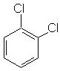 | 1,2-dichlorobenzene
 |  | m-dichlorobenzene | 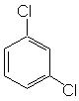 | 1,3-dichlorobenzene
 |  | p-dichlorobenzene | 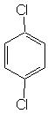 | 1,4-dichlorobenzene
 |  | o-bromochlorobenzene | 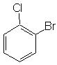 | 1-bromo-2-chlorobenzene
 |  | m-bromochlorobenzene | 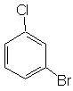 | 1-bromo-3-chlorobenzene
 |  | p-bromochlorobenzene | 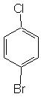 | 1-bromo-4-chlorobenzene
 |  | o-chloroiodobenzene | 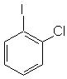 | 1-chloro-2-iodobenzene
 |  | m-chloroiodobenzene | 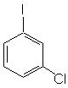 | 1-chloro-3-iodobenzene
 |  | p-chloroiodobenzene | 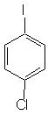 | 1-chloro-4-iodobenzene
 |  | 1,2,3-trichlorobenzene
 |  | 1,2,4-trichlorobenzene
 |  | 1,2,5-trichlorobenzene
 |  | 1,3,5-trichlorobenzene
 |  | 1-bromo-2,3-dichlorobenzene
 |  | 1-bromo-2,4-dichlorobenzene
 |  | 1-bromo-2,5-dichlorobenzene
 |  | 2-bromo-1,3-dichlorobenzene
 |  | 4-bromo-1,2-dichlorobenzene
 |  | 1-chloro-2,3-difluororobenzene
 |  | 1-chloro-2,4-difluororobenzene
 |  | 1-chloro-2,5-difluororobenzene
 |  | 2-chloro-1,3-difluororobenzene
 |  | 4-chloro-1,2-difluororobenzene
 |  | o-chloroaniline | 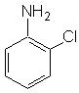 | 2-chloroaniline
 |  | m-chloroaniline | 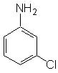 | 3-chloroaniline
 |  | p-chloroaniline | 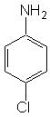 | 4-chloroaniline
 |  | o-chlorophenol | 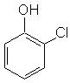 | 2-chlorophenol
 |  | m-chlorophenol | 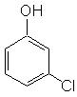 | 3-chlorophenol
 |  | p-chlorophenol | 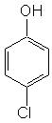 | 4-chlorophenol
 |  | o-chlorobenzaldehyde | 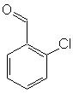 | 2-chlorobenzaldehyde
 |  | m-chlorobenzaldehyde | 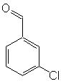 | 3-chlorobenzaldehyde
 |  | p-chlorobenzaldehyde | 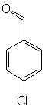 | 4-chlorobenzaldehyde
 |  | o-chlorobenzoic acid |  | 2-chlorobenzoic acid
 |  | m-chlorobenzoic acid |  | 3-chlorobenzoic acid
 |  | p-chlorobenzoic acid |  | 4-chlorobenzoic acid
 |  | o-chlorotoluene | 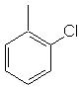 | 2-chlorotoluene
 |  | m-chlorotoluene | 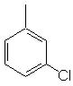 | 3-chlorotoluene
 |  | p-chlorotoluene | 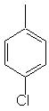 | 4-chlorotoluene
 |  | o-nitroaniline |  | 2-nitroaniline
 |  | m-nitroaniline |  | 3-nitroaniline
 |  | p-nitroaniline |  | 4-nitroaniline
 |  | o-nitrophenol |  | 2-nitrophenol
 |  | m-nitrophenol |  | 3-nitrophenol
 |  | p-nitrophenol |  | 4-nitrophenol
 |  | o-nitrobenzaldehyde |  | 2-nitrobenzaldehyde
 |  | m-nitrobenzaldehyde |  | 3-nitrobenzaldehyde
 |  | p-nitrobenzaldehyde |  | 4-nitrobenzaldehyde
 |  | o-nitrobenzoic acid |  | 2-nitrobenzoic acid
 |  | m-nitrobenzoic acid |  | 3-nitrobenzoic acid
 |  | p-nitrobenzoic acid |  | 4-nitrobenzoic acid
 |  | o-nitrotoluene |  | 2-nitrotoluene
 |  | m-nitrotoluene |  | 3-nitrotoluene
 |  | p-nitrotoluene |  | 4-nitrotoluene
 |  | o-methylaniline | 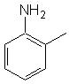 | 2-methylaniline
 |  | m-methylaniline | 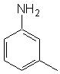 | 3-methylaniline
 |  | p-methylaniline | 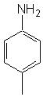 | 4-methylaniline
 |  | o-methylphenol | 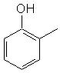 | 2-methylphenol
 |  | m-methylphenol | 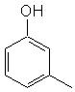 | 3-methylphenol
 |  | p-methylphenol | 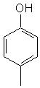 | 4-methylphenol
 |  | o-methylbenzaldehyde | 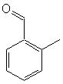 | 2-methylbenzaldehyde
 |  | m-methylbenzaldehyde | 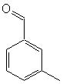 | 3-methylbenzaldehyde
 |  | p-methylbenzaldehyde | 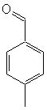 | 4-methylbenzaldehyde
 |  | o-methylbenzoic acid | 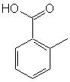 | 2-methylbenzoic acid
 |  | m-methylbenzoic acid | 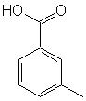 | 3-methylbenzoic acid
 |  | p-methylbenzoic acid | 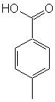 | 4-methylbenzoic acid
 |  | o-methyltoluene | 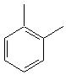 | 2-methyltoluene
 |  | m-methyltoluene | 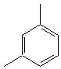 | 3-methyltoluene
 |  | p-methyltoluene | 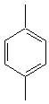 | 4-methyltoluene
 |  | o-ethylaniline | 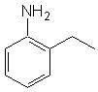 | 2-ethylaniline
 |  | m-ethylaniline | 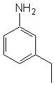 | 3-ethylaniline
 |  | p-ethylaniline | 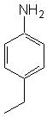 | 4-ethylaniline
 |  | o-ethylphenol | 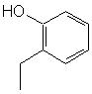 | 2-ethylphenol
 |  | m-ethylphenol | 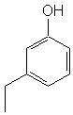 | 3-ethylphenol
 |  | p-ethylphenol | 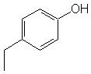 | 4-ethylphenol
 |  | o-ethylbenzaldehyde | 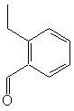 | 2-ethylbenzaldehyde
 |  | m-ethylbenzaldehyde | 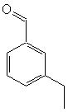 | 3-ethylbenzaldehyde
 |  | p-ethylbenzaldehyde | 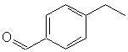 | 4-ethylbenzaldehyde
 |  | o-ethylbenzoic acid |  | 2-ethylbenzoic acid
 |  | m-ethylbenzoic acid |  | 3-ethylbenzoic acid
 |  | p-ethylbenzoic acid |  | 4-ethylbenzoic acid
 |  | o-ethyltoluene | 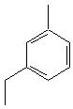 | 2-ethyltoluene
 |  | m-ethyltoluene |  | 3-ethyltoluene
 |  | p-ethyltoluene | 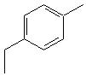 | 4-ethyltoluene
 |  | 3-bromo-1-chloroaniline | 2x names, wrong b/c can’t have something on one with aniline
 |  | 4-bromo-1-chloroaniline
 |  | 5-bromo-1-chloroaniline
 |  | 6-bromo-1-chloroaniline
 |  | 2-bromo-3-chloroaniline
 |  | 2-bromo-4-chloroaniline
 |  | 2-bromo-5-chloroaniline
 |  | 2-bromo-6-chloroaniline
 |  | 3-bromo-1-chlorophenol
 |  | 4-bromo-1-chlorophenol
 |  | 5-bromo-1-chlorophenol
 |  | 6-bromo-1-chlorophenol
 |  | 2-bromo-3-chlorophenol
 |  | 2-bromo-4-chlorophenol
 |  | 2-bromo-5-chlorophenol
 |  | 2-bromo-6-chlorophenol
 |  | 3-bromo-1-chlorobenzaldehyde
 |  | 4-bromo-1-chlorobenzaldehyde
 |  | 5-bromo-1-chlorobenzaldehyde
 |  | 6-bromo-1-chlorobenzaldehyde
 |  | 2-bromo-3-chlorobenzaldehyde
 |  | 2-bromo-4-chlorobenzaldehyde
 |  | 2-bromo-5-chlorobenzaldehyde
 |  | 2-bromo-6-chlorobenzaldehyde
 |  | 3-bromo-1-chlorobenzoic acid
 |  | 4-bromo-1-chlorobenzoic acid
 |  | 5-bromo-1-chlorobenzoic acid
 |  | 6-bromo-1-chlorobenzoic acid
 |  | 2-bromo-3-chlorobenzoic acid
 |  | 2-bromo-4-chlorobenzoic acid
 |  | 2-bromo-5-chlorobenzoic acid
 |  | 2-bromo-6-chlorobenzoic acid
 |  | 3-bromo-2-chlorotoluene
 |  | 4-bromo-2-chlorotoluene
 |  | 5-bromo-2-chlorotoluene | 4-bromo-1-chloro-2-methylbenzene
 |  | 6-bromo-2-chlorotoluene
 |  | 2-bromo-3-chlorotoluene
 |  | 2-bromo-4-chlorotoluene
 |  | 2-bromo-5-chlorotoluene
 |  | 2-bromo-6-chlorotoluene

