CHE 102 – Ch 24 - Ketal

Total # Carbons | # C Main Chain | IUPAC Name | Linear Structure | Structural Formula
5 |  | 2,2-dimethoxypropane | 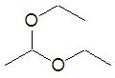
6 |  | 2,2-dimethoxybutane | 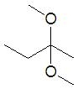
 |  | 2-ethoxy-2-methoxypropane | 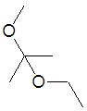
7 |  | 2,2-dimethoxypentane | 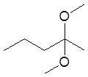
 |  | 3,3-dimethoxypentane | 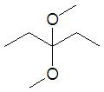
 |  | 2,2-dimethoxy-3-methylbutane | 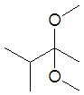
 |  | 2-ethoxy-2-methoxy-3-methylbutane | 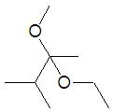
 |  | 2,2-diethoxypropane | 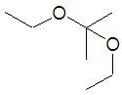
 |  | 2-ethoxy-2-propoxypropane | 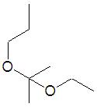
8 |  | 2,2-dimethoxyhexane
 |  | 3,3-dimethoxyhexane
 |  | 2,2-dimethoxy-3-methylpentane
 |  | 2,2-dimethoxy-4-methylpentane
 |  | 2-ethoxy-2-methoxypentane
 |  | 3-ethoxy-3-methoxypentane
 |  | 3,3-dimethoxy-2-methylpentane
 |  | 2,2-dimethoxy-2,2-dimethylbutane
 |  | 2-ethoxy-2-methoxy-3-methylbutane
 |  | 2,2-diethoxybutane
 |  | 2-methoxy-2-propoxybutane
 |  | 2-ethoxy-2-propoxypropane
 |  | 2-butoxy-2-methoxypropane

