CHE 102 – Ch 24 - Hemicetal

Total # Carbons | # C Main Chain | IUPAC Name | Linear Structure | Structural Formula
3 |  | 1-hydroxy-1-methoxyethane | 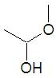
4 |  | 1-hydroxy-1-methoxypropane | 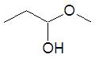
 |  | 1-hydroxy-1-ethoxyethane | 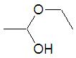
5 |  | 1-hydroxy-1-methoxybutane | 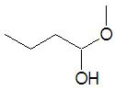
 |  | 1-hydroxy-1-ethoxypropane | 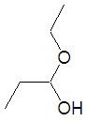
 |  | 1-hydroxy-1-propoxyethane | 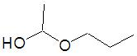
6 |  | 1-hydroxy-1-methoxypentane | 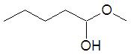
 |  | 1-hydroxy-1-ethoxybutane | 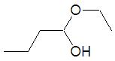
 |  | 1-hydroxy-1-propoxypropane | 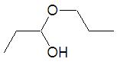
 |  | 1-hydroxy-1-butoxyethane | 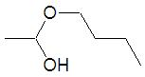
7 |  | 1-hydroxy-1-methoxyhexane
 |  | 1-hydroxy-1-ethoxypentane
 |  | 1-hydroxy-1-propoxybutane
 |  | 1-hydroxy-1-butoxypropane
 |  | 1-hydroxy-1-pentoxyethane
8 |  | 1-hydroxy-1-methoxyheptane
 |  | 1-hydroxy-1-ethoxyhexane
 |  | 1-hydroxy-1-propoxypentane
 |  | 1-hydroxy-1-butoxybutane
 |  | 1-hydroxy-1-pentoxypropane
 |  | 1-hydroxy-1-hexoxyethane

