CHE 102 – Ch 24 - Acetal

Total # Carbons | # C Main Chain | IUPAC Name | Linear Structure | Structural Formula
4 |  | 1,1-dimethoxyethane | 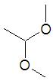
5 |  | 1,1-dimethoxypropane | 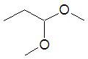
 |  | 1-ethoxy-1-methoxyethane | 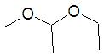
6 |  | 1,1-dimethoxybutane | 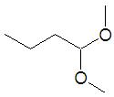
 |  | 1,1-dimethoxy-2-methylpropane | 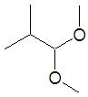
 |  | 1-ethoxy-1-methoxypropane | 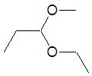
 |  | 1,1-diethoxyethane | 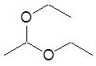
7 |  | 1,1-dimethoxypentane
 |  | 1,1-dimethoxy-2-methylbutane
 |  | 1,1-dimethoxy-3-methylbutane
 |  | 1,1-dimethoxy-2,2-dimethylpropane
 |  | 1-methoxy-1-propoxypropane
 |  | 1,1-diethoxypropane
 |  | 1-ethoxy-1-propxyethane
 |  | 1-methoxy-1-butoxyethane
8 |  | 1,1-dimethoxyhexane
 |  | 1,1-dimethoxy-2-methylpentane
 |  | 1,1-dimethoxy-3-methylpentane
 |  | 1,1-dimethoxy-4-methylpentane
 |  | 1-ethoxy-1-methoxypentane
 |  | 1,1-dimethoxy-3,3-dimethylbutane
 |  | 1,1-diethoxybutane
 |  | 1-methoxy-1-propoxybutane
 |  | 1-butoxy-1-methoxypropane
 |  | 1-ethoxy-1-propoxypropane
 |  | 1,1-dipropoxyethane
 |  | 1-methoxy-1-pentoxyethane
 |  | 1-butoxy-1-ethoxyethane

