CHE 102 – Misc - Haloalkanes

Total # Carbons | # C Main Chain | IUPAC Name | Linear Structure | Structural Formula
1 | 1 | chloromethane
2 | 2 | chloroethane
3 | 3 | 1-chloropropane
 |  | 2-chloropropane | 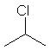
4 | 4 | 1-chlorobutane
 |  | 2-chlorobutane | 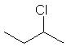
 | 3 | 1-chloro-2-methylpropane | 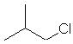
 |  | 2-chloro-2-methylpropane | 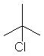
5 | 5 | 1-chloropentane
 |  | 2-chloropentane | 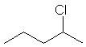
 |  | 3-chloropentane | 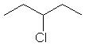
 | 4 | 1-chloro-2-methylbutane | 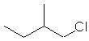
 |  | 1-chloro-3-methylbutane | 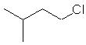
 |  | 2-chloro-2-methylbutane | 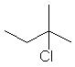
 |  | 2-chloro-3-methylbutane | 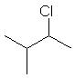
 | 3 | 1-chloro-2,2-dimethylpropane | 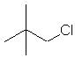
6 | 6 | 1-chlorohexane
 |  | 2-chlorohexane | 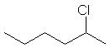
 |  | 3-chlorohexane | 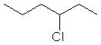
 | 5 | 1-chloro-2-methylpentane | 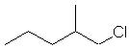
 |  | 2-chloro-2-methylpentane | 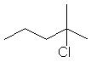
 |  | 3-chloro-2-methylpentane | 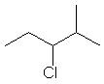
 |  | 2-chloro-4-methylpentane | 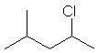
 |  | 1-chloro-4-methylpentane | 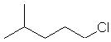
 |  | 1-chloro-3-methylpentane | 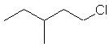
 |  | 2-chloro-3-methylpentane | 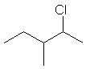
 |  | 3-chloro-3-methylpentane | 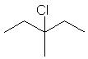
 | 4 | 1-chloro-2,2-dimethylbutane | 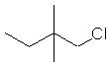
 |  | 2-chloro-3,3-dimethylbutane | 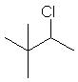
 |  | 1-chloro-3,3-dimethylbutane | 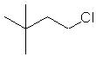
 |  | 1-chloro-2,3-dimethylbutane | 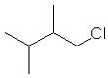
 |  | 2-chloro-2,3-dimethylbutane | 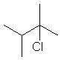
7 | 7 | 1-chloroheptane
 |  | 2-chloroheptane | 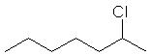
 |  | 3-chloroheptane | 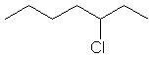
 |  | 4-chloroheptane | 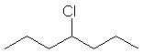
 | 6 | 1-chloro-2-methylhexane | 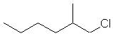
 |  | 2-chloro-2-methylhexane | 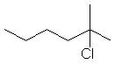
 |  | 3-chloro-2-methylhexane | 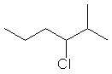
 |  | 4-chloro-2-methylhexane | 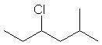
 |  | 2-chloro-5-methylhexane | 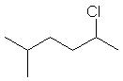
 |  | 1-chloro-5-methylhexane | 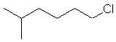
 |  | 1-chloro-3-methylhexane | 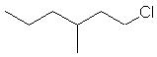
 |  | 2-chloro-3-methylhexane | 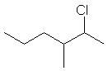
 |  | 3-chlroro-3-methylhexane | 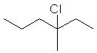
 |  | 3-chlroro-4-methylhexane | 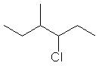
 |  | 2-chlroro-4-methylhexane | 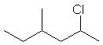
 |  | 1-chlroro-4-methylhexane | 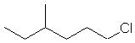
 | 5 | 1-chloro-3-ethylpentane | 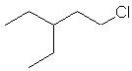
 |  | 2-chloro-3-ethylpentane | 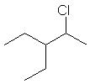
 |  | 3-chloro-3-ethylpentane | 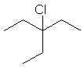
 |  | 1-chloro-2,2-dimethylpentane | 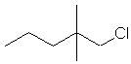
 |  | 3-chloro-2,2-dimethylpentane | 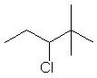
 |  | 4-chloro-2,2-dimethylpentane | 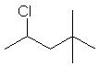
 |  | 1-chloro-4,4-dimethylpentane | 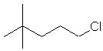
 |  | 1-chloro-2,3-dimethylpentane | 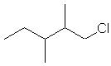
 |  | 2-chloro-2,3-dimethylpentane | 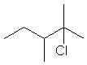
 |  | 3-chloro-2,3-dimethylpentane | 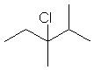
 |  | 2-chloro-3,4-dimethylpentane | 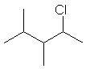
 |  | 1-chloro-3,4-dimethylpentane | 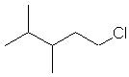
 |  | 1-chloro-2,4-dimethylpentane | 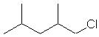
 |  | 2-chloro-2,4-dimethylpentane | 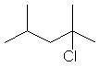
 |  | 3-chloro-2,4-dimethylpentane | 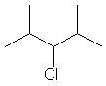
 |  | 1-chloro-3,3-dimethylpentane | 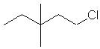
 |  | 2-chloro-3,3-dimethylpentane | 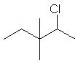
 | 4 | 1-chloro-2,3,3-trimethylbutane | 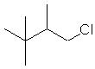
 |  | 2-chloro-2,3,3-trimethylbutane | 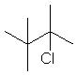
 |  | 1-chloro-2,2,3-trimethylbutane | 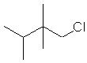
8 | 8 | 1-chlorooctane
 |  | 2-chlorooctane | 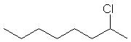
 |  | 3-chlorooctane | 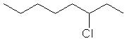
 |  | 4-chlorooctane | 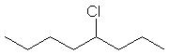
 | 7 | 1-chloro-2-methyloctane | 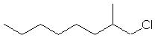
 |  | 2-chloro-2-methyloctane | 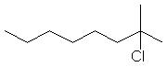
 |  | 3-chloro-2-methyloctane | 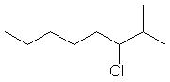
 |  | 4-chloro-2-methyloctane | 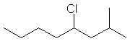
 |  | 5-chloro-2-methyloctane | 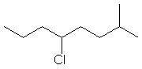
 |  | 6-chloro-2-methyloctane | 